**INCIDENT MANAGEMENT SYSTEM**

**A PROJECT REPORT**

**Submitted By**

**SHIVANGI SAXENA**

**University Roll No 1900290140035**

**Submitted in partial fulfilment of**

**the Requirements for the Degree**

**of**

**MASTER OF COMPUTER APPLICATION**

**Under the Supervision of**

**Vidushi Mishra**

**ASSOCIATE PROFESSOR**



**Submitted to**

**DEPARTMENT OF COMPUTER**

**APPLICATION**

**KIET Group of Institutions, Ghaziabad Uttar**

**Pradesh-201206**

**(JUNE 2022)**

**Declaration**

I undersigned hereby declare that the project report ( "**INCIDENT MANAGEMENT SYSTEM"**) , submitted for partial fulfillment of the requirements for the requirement for the award of the degree of Master of Computer Applications by the ‘KIET GROUP OF INSTITUTION’S GHAZIABAD’ is a bonafide work done by me under supervision of (Pro. Vidhushi Mishra). This submission represents my ideas in my own words and where ideas or words of others have been included, I have adequately and accurately cited and referenced the original sources. I also declare that I have adhered to ethics of academic honesty and integrity and have not misrepresented or fabricated any data or idea or fact or source in my submission.

Name : SHIVANGI SAXENA

Roll No: 1900290140035

Branch: MCA (6th Sem)

**(Candidate Signature)**

shivangi saxena

**Certificate**

Certified that **SHIVANGI SAXENA (enrollment no. 190029014005178)** has carried out the project work having “incident management system” for Master of Computer Applications from Dr. A.P.J. Abdul Kalam Technical University (AKTU) (formerly UPTU), Technical University, Lucknow under my supervision. The project report embodies original work, and studies are carried out by the student herself and the contents of the project report do not form the basis for the award of any other degree to the candidate or to anybody else from this or any other University/Institution.

**Date:**

This is to certify that the above statement made by the candidate is correct to the best

of my knowledge.

**Date**:

**Pro. Vidhushi Mishra**

**Associate Professor**

**Department of Computer Applications**

**KIET Group of Institutions, Ghaziabad**

**Signature of Internal Examiner Signature of External Examiner**

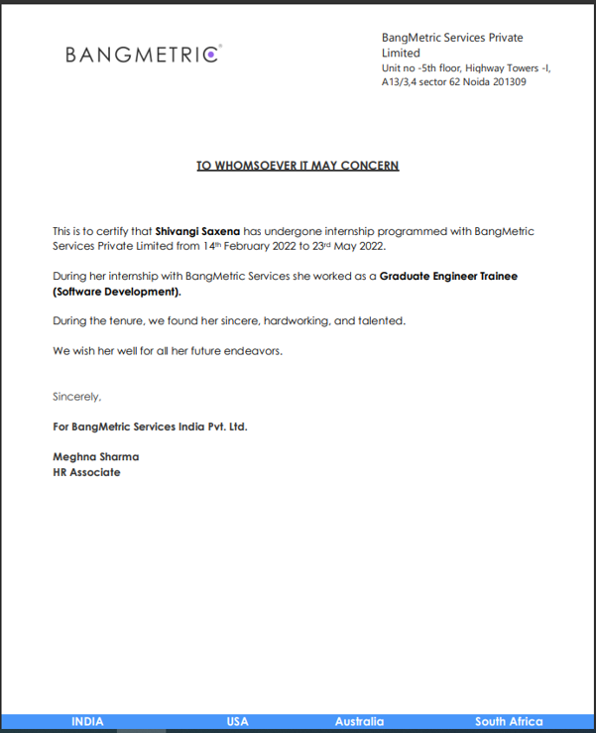

**// Title**

**// Your name**

**Abstract**

An incident management system is a web application used as an unplanned interruption or a reduction in the quality of a technical service or a failure of a configuration item (CI) that has not yet impacted a technical service. Incidents can include failures or degradation of services

reported by users, technical staff, third-party suppliers and partners, or automatically from monitoring tools. Normal service operation is defined as an operational state where services and CIs are performing within agreed service and operational levels. Incident management is responsible for managing the lifecycle of all incidents. A temporary workaround to restore service is all that is required in many cases to complete the process. The objectives of Incident Management are to:•Ensure standard methods and procedures are used for efficient and prompt incident response, analysis, documentation, management, and reporting. •Increase visibility and communication of incidents to business and support staff. •Enhance business perception of IT through use of a professional approach in quickly resolving and communicating incidents when they occur. •Align Incident Management activities and priorities with those of the business. •Maintain user satisfaction with the quality of IT services.

**ACKNOWLEDGEMENTS**

I wish to record my heartfelt gratitude and sincere thanks to Pro. Vidushi Mishra, Asst. Professor, Department of Computer Applications, KIET Group of Institutions, Ghaziabad, for his kind support and inspiration given to me till the end of my project.

Words are not enough to express my gratitude to Dr. Ajay Kumar Shrivastava, Professor and Head, Department of Computer Applications, for his insightful comments and administrative help at various occasions.

Fortunately, I have many understanding friends, who have helped me a lot on many critical conditions.And I also want to thank my organization members who helped me in completing my project.

Finally, my sincere thanks go to my family members and all those who have directly and indirectly provided me moral support and other kind of help. Without their support, completion of this work would not have been possible in time. They keep my life filled with enjoyment and happiness.

**shivangi saxena**

**Table of Contents**

|  |  |  |
| --- | --- | --- |
| **S.No** | **Tittle** | **Page** |
|  | Declaration | 2 |
|  | Certificate | 4 |
|  | Abstract | 5 |
|  | ACKNOWLEDGEMENTS | 6 |
| CHAPTER 1 | INTRODUCTION | 9 |
| 1.1 | PROJECT DESCRIPION | 9 |
| 1.2 | PROJECT SCOPE | 9 |
| 1.3 | Hardware/Software used in Project | 10 |
| CHAPTER 2 | TECHNICAL FEASIBILITY | 12 |
| 2.1 | Operational Feasibility | 12 |
| 2.2 | Technical Feasibility | 12 |
| 2.3 | Technology Description | 13 |
| CHAPTER 3 | BACKEND DESIGN | 18 |
| 3.1 | MySQL | 18 |
| 3.2 | Database views | 19 |
| 3.3 | Data dictionary tables | 20 |
| CHAPTER 4 | INCIDENT MANAGEMENT | 21 |
| 4.1 | Process flow of incident management | 21 |
| 4.2 | Case resolved with incident management | 23 |
| 4.3 | Case resolved with service portal | 23 |
| 4.4 | Personal developer instance | 26 |
| 4.5 | App menu | 26 |
| 4.5.1 | img | 27 |
| 4.5.2 | img | 28 |
| 4.5.3 | img | 29 |
| 4.5.6 | Caller field | 30 |
| 4.5.7 | Img-referece specification | 31 |
| Chapter-5 | CONFIGURATION ITEM | 32 |
| 5.1 | category | 32 |
| 5.2 | Img-subcategory | 33 |
| 5.4 | Img-subcategory | 34 |
| 5.5 | Impact,urgency,priority | 34 |
| Chapter-6 | USER INTERFACE POLICIES | 35 |
| 6.1 | Img-ui policy for priority | 35 |
| 6.2 | Short description | 35 |
| 6.3 | opened | 36 |
| 6.4 | Opened by | 36 |
| 6.5 | Contact type | 37 |
| 6.6 | Assignment group | 37 |
| 6.7 | Business duration | 38 |
| 6.8 | state | 39 |
| Chapter-7 | USER INTERFACE ACTIONS | 40 |
| 7.1 | Img-resolve incident | 40 |
| 7.2 | Copy for telecom | 41 |
| Chapter-8 | CONFIGURATION ITEMS | 45 |
| 8.1 | Flash CI information | 45 |
| 8.2 | Create incident | 46 |
| Chapter-9 | CLIENT SCRIPT | 50 |
| 9.1 | Show replacement popup | 51 |
| 9.2 | Modify work notes label | 54 |
| 9.3 | Set review trigger fields | 55 |
| 9.4 | Hide choice- closed | 57 |
| 9.5 | Hide attachment link when closed | 58 |
| 9.6 | Warranty expiration alert | 58 |
| 9.7 | Close mandatory on close/resolve | 61 |
| 9.8 | Hide close notes and code | 63 |
| 9.9 | Transfer popup | 66 |
| 9.10 | Modify comments label | 68 |
| Chapter-10 | BUSINESS RULES | 74 |
| 10.1 | Display BR | 74 |
| 10.2 | Before BR | 74 |
| 10.3 | After BR | 74 |
| 10.4 | Async BR | 75 |
| 10.5 | Abort assignment if CI is empty | 75 |
| 10.6 | Img-state is resolved/close notes | 82 |
| 10.7 | Prevent close notes from list view | 83 |
| 10.8 | Response from user | 84 |
| 10.9 | Incident closed | 90 |
| 10.10 | Incident survey | 91 |
| 10.11 | Service level agreement(SLA) | 93 |
| Chapter-11 | ADVANTAGE | 94 |
|  | CONCLUSION | 96 |
|  | REFERENCES(1 to 15) | 97 |
|  |  |  |
|  |  |  |

**CHAPTER 1**

**INTRODUCTION**

**1.1 PROJECT DESCRIPION**

Incident Management system is a web application which is based on servicenow ITSM module.

The primary goal of implementing this application is to improve IT efficiencies and reduce IT operational costs.Additional goals and expected outcomes include:

•Improved overall effectiveness of IT service delivery

•Expanded visibility into operations and performance metrics

•Strong controls and governance

•Superior customer experience

•Enriched communications, both incoming and outgoing

•Increased accountability

**1.2 PROJECT SCOPE**

Incident management system is a cloud-based ITSM based web application.. It provides higher flexibility relative to functionality, reliability and  
customization. Presented as an ITSM tool it has now grown and progressed fairly more than being just an ITSM device as it helps in solving incident of many types of programs in the websites of finance, sales, HR etc. It is due to its affectivity that it has got a great hold in the industry and has obtained a huge business. With the execution of ServiceNow, all we got to do is to think running our business and forget about managing the other tools like- infrastructure, database, servers, security, data centres, clustering, load balancing, etc.

ServiceNow is implemented by companies from almost all the fields that provide service and support like the automobile industry, IT industry, medication, insurance, media and enjoyment etc. Few IT companies have fought with an obsolete ITSM system in the past. They felt that this would attract them back in the global industry in terms of service quality. This future insecurity forced IT companies to outsource their management and maintenance issues. It leads to customer dissatisfaction resulting over expenditure and ended up being time-consuming. With ServiceNow, the IT companies are able to work with all the departments on a single platform which helps you to save both time and money.

**1.3 Hardware / Software used in Project**

**1.3.1 Hardware Requirements**

The most common set of requirements defined by any operating system or software application is the physical computer resources, also known as hardware.

Memory – All software, when run, resides in the random access memory (RAM) of a

computer. Memory requirements are defined after considering demands of the application, operating system, supporting software and files, and other running processes. Optimal performance of other unrelated software running on a multi-tasking computer system is also considered when defining this requirement.

|  |  |
| --- | --- |
| Number | Description |
| 1 | PC with any GB of Hard disk |
| 2 | Good internet connection. |
|  |  |

**Table 1.1 Hardware Requirements**

**1.3.2 Software Requirements**

The software requirements are description of features and functionalities of the target system. Requirements convey the expectations of users from the software product. The requirements can be obvious or hidden, known or unknown, expected or unexpected from client’s point of view .Every project needs

software. We should try to understand what sort of requirements may arise in the requirement elicitation phase and what kinds of requirements are expected from the software system.

|  |  |  |
| --- | --- | --- |
| Number | Description | Type |
| 1 | Operating System | Windows XP / Windows |
| 2 | Language | JavaScript, HTML,  CSS |
| 3 | Database | MySQL |
| 4 | PDI | Service Now |
| 5 | Browser | Google Chrome / Internet Explorer |

**Table 1.2 Software Requirements**

**//chapter 2 : literature review**

**CHAPTER 2**

**TECHNICAL FEASIBILITY**

**FEASIBILITY STUDY**

A feasibility study is a high-level capsule version of the entire System analysis and Design Process. The study begins by classifying the problem definition. Feasibility is to determine if it’s worth doing. Once an acceptance problem definition has been generated, the analyst develops a logical model of the system. A search for alternatives is analyzed carefully. There are 3 parts in feasibility study.

**2.1 Operational Feasibility**

Operational feasibility is the measure of how well a proposed system solves the problems, and takes advantage of the opportunities identified during scope definition and how it satisfies the requirements identified in the requirements analysis phase of system development. The operational feasibility assessment focuses on the degree to which the proposed development projects fits in with the existing business environment and objectives with regard to development schedule, delivery date, corporate culture and existing business processes. To ensure success, desired operational outcomes must be imparted during design and development. These include such design-dependent parameters as reliability, maintainability, support-ability , usability, product-ability, sustainability, affordability and others. These parameters are required to be considered at the early stages of design if desired operational behaviour are to be realized. A system design and development require appropriate and timely application of engineering and management efforts to meet the previously mentioned parameters. A system may serve its intended purpose most effectively when its technical and operating characteristics are engineered into the design. Therefore, operational feasibility is a critical aspect of systems engineering that needs to be an integral part of the early design phases.

**2.2 TECHNICAL FEASIBILITY**

This involves questions such as whether the technology needed for the system exists, how difficult it will be to build, and whether the firm has enough experience using that technology. The assessment is based on outline design of system requirements in terms of input, processes, output, fields, programs and procedures. This can be qualified in terms of volume of data, trends, frequency of updating in order to give an introduction to the technical system. The application is the fact that it has been developed on windows XP platform and a high configuration of 1GB RAM on Intel Pentium Dual core processor. This is technically feasible. The technical feasibility assessment is focused on gaining an understanding of the present technical resources of the organization and their applicability to the expected needs of the proposed system. It is an evaluation of the hardware and software and how it meets the need of the proposed system.

**2.3 Technology Description**

**2.3.1 ServiceNow**

`ServiceNow is a cloud based platform, which was mainly developed for workflow and process automation as per the ITIL principles. However, it is highly customisable and also can be used for other purposes. ServiceNow is an American based company and was founded in 2004 by Fred Luddy. It has a unique way for naming its versions. They name the versions based on the major cities of the world. The latest version of ServiceNow is Orlando.

ServiceNow offers many ready to use solutions, workflows and products for an organisation. The organisation can develop the customised applications and modules as per the business requirement using the ServiceNow scripting and existing tools.

**2.3.2 Services of ServiceNow**

Some of the important offerings and most widely used services of ServiceNow are explained below −

**IT Service management**

ServiceNow is mainly used as a ticketing tool to manage incidents, problems and changes. It has many advanced features, analytics and insights that impacts the speed and delivery of IT.

**HR management**

ServiceNow can be used for almost all HR delivery services like leave management, timesheet management, employee document management, new onboarding management, performance management, etc.

**IT Asset management**

With ServiceNow, we can manage our hardware and software assets to optimise cost and increase efficiency. ServiceNow has features such as licence management, warranty management, CI management, advanced reporting and insights, etc.

**Finance operation management**

ServiceNow manages all the activities related to finance close and automates the financial processes.

Apart from offerings mentioned above, ServiceNow also offers services for IT business management, security operations, virtual chatbots, etc.

ServiceNow is built using Java and Tomcat web server running on Linux. Although to develop new modules and applications in ServiceNow the JavaScript knowledge is sufficient.

**2.3.3 ServiceNow Instance**

A ServiceNow instance is a set of databases, applications, virtual machines, libraries grouped together to provide the required services to a specific customer. ServiceNow customer instance is built on multi-instance architecture.

The figure given below shows multi-instance architecture

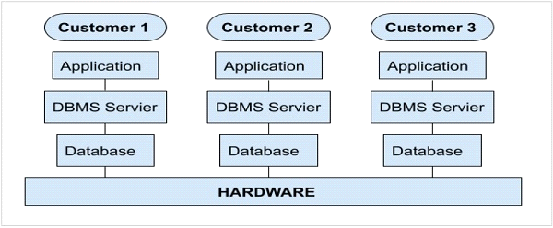

**Fig.2.1 Multi-instance architecture**

The important point to note here is that, each customer has a separate customised application(s) along with separate database(s) running on shared hardware resources. The customer data is encrypted and therefore, is completely secure. The deployment of ServiceNow is very flexible and it can also be implemented in a private cloud.

ServiceNow also offers developer instance, which is a community edition free of cost. ServiceNow developer instance was launched, to promote the use of ServiceNow and to provide the resources, so that the developers/administrators can learn, build, enhance and customise the applications in ServiceNow.

**2.4 Technology used in project**

**ServiceNow ITSM Module**

Improved employee and customer experiences are essential for successful digital transformation. However, using siloed IT tools for your digital transformation creates information silos. With disparate data, processes and excessive amounts of time and money spent on firefighting, you’re left with limited resources to create delightful employee experiences.

ServiceNow IT Service Management (ITSM) is a modern, cloud-based, silo-busting service management solution. With ServiceNow ITSM, you can consolidate on-premises legacy tools to a single cloud platform and stop wasting your money and harness shared data and analytic with automated workflows on the Now Platform® in the Nonstop cloud. Platform-native AI and machine learning along with natural language virtual agent chat-bots unburden your IT staff and boost productivity 30%. ServiceNow ITSM lets you:

* Empower employees to self-solve issues 24/7, raise questions, and get relevant, accurate, and consistent information to improve
* employee satisfaction.
* Make smarter decisions, automate 20%1 of your services, and continually improve your services in role-based workspace.
* Triage, collaborate, and enable agents to resolve incidents, find answers, and stay connected from anywhere to resolve high impact incidents and improve agent productivity by 30%

**Performance Analytic**

Enable stakeholders—workers, owners, and executives— responsible for service delivery to make smarter, real-time decisions with Performance Analytic. Use data visualizations to anticipate trends, prioritize resources, and drive IT alignment with business goals.

**Continual Improvement Management**

Collaborate and prioritize data, people, and business goals to manage your strategic IT road-map investments with the structured framework and workflow of Continual Improvement Management (CIM).

**CHAPTER 3**

**BACKEND DESIGN**

**3.1 MySQL**

MySQL is an open-source, fast reliable, and flexible relational database management system, typically used with PHP. This chapter is an introductory chapter about MySQL, what is MySQL, and the main features of MySQL are described here

**3.1.1 What is MySQL**

* MySQL is a database system used for developing web-based software applications.
* MySQL used for both small and large applications.
* MySQL is a relational database management system (RDBMS).
* MySQL is fast, reliable, and flexible and easy to use.
* MySQL supports standard SQL (Structured Query Language).
* MySQL is free to download and use.
* MySQL was developed by Michael Widenius and David Axmark in 1994.
* MySQL is presently developed, distributed, and supported by Oracle Corporation.
* MySQL Written in C, C++.

**3.1.2Main Feature of MySQL**

* MySQL server design is multi-layered with independent modules

.

* MySQL is fully multi-threaded by using kernel threads. It can handle multiple

CPUs if they are available.

* MySQL provides transactional and non-transactional storage engines.
* MySQL has a high-speed thread-based memory allocation system

.

* MySQL supports in-memory heap table.
* MySQL Handles large databases.
* MySQL Server works in client/server or embedded systems.
* MySQL Works on many different platforms.

**3.2 Database views**

A database view defines table joins for reporting purposes.

For example, a database view can join the Incident table to the Metric Definition and Metric Instance tables. This view can be used to report on incident metrics and may include fields from any of these three tables.

Several useful database views are installed with the Database View plugin and the Database Views for Service Management plugin. These database views cover most metric reporting needs and greatly reduce the need to define new ones.

Any user who can create a report can use database views as the report source, but ACLs on the underlying tables are honored.

**Note:**

* The accumulated impact on performance grows as the number of tables that are included in the view and the number of records that those tables contain increases. To maximize the performance of the database view, ensure that the ‘where’ clauses that are defined in the database view are based on indexed fields.
* A database view is not treated like a custom table, so there is no licensing impact.

**3.3 Data dictionary tables**

The system defines data dictionary, data modeling, and entity relationship information in multiple tables.

* Tables [sys_db_object]: Contains a record for each table.
* Dictionary Entries [sys_dictionary]: Contains additional details for each table and the definition for every column on each table. Each row represents either a column on a table or a table.
* Field Labels [sys_documentation]: Contains the human-readable labels and language information.

**Tables**

The Tables [sys_db_object] table contains a record for each table in the database.

Access the Tables list by navigating to System Definition > Tables. Administrators can create a custom table, add or modify columns in a searchable and sortable embedded list, and define the auto-number format.

The following image shows a list of the tables that extend the Application File table.

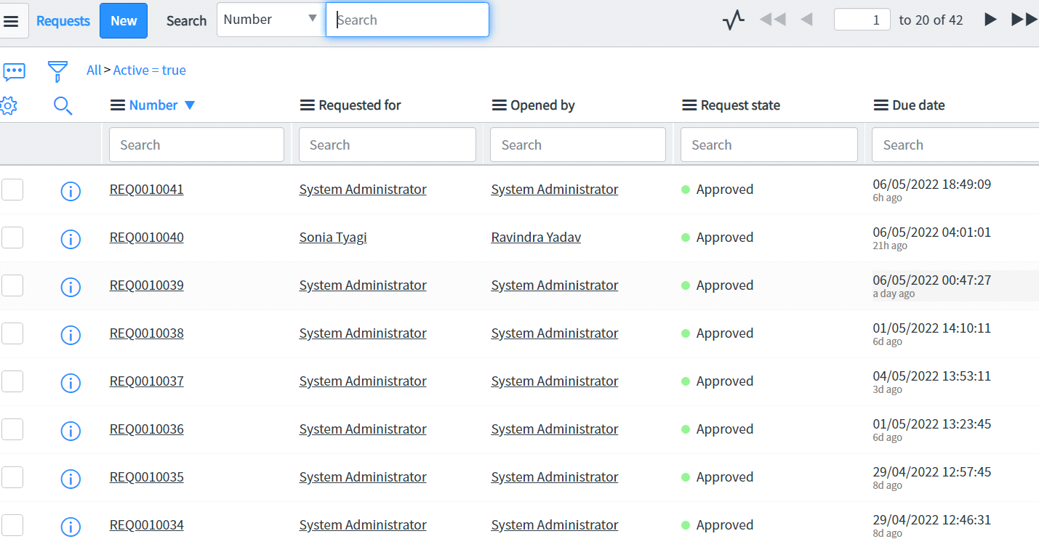

**Img 3.1 Extended Application File table**

**CHAPTER 4**

**INCIDENT MANAGEMENT**

**4.1 Process flow of incident management**

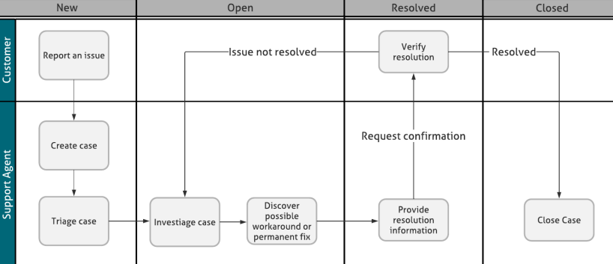

Img-4.1.1

**4.2Case resolved with incident management**

Use Case Management along with Incident Management to restore service disruptions such as outages that impact one or more customers. Support agent can create an incident from case and assign it to the external department/ team responsible for supporting the impacted service

. 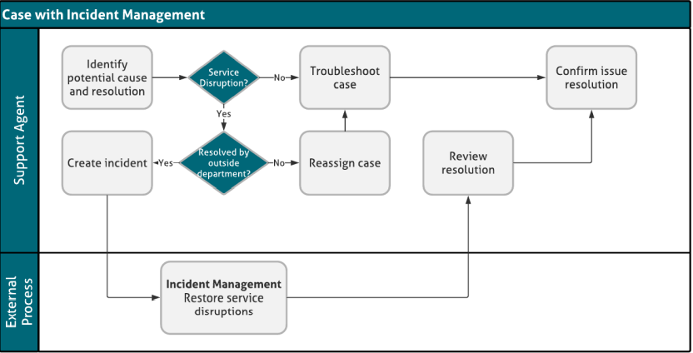

Img-4.2.1

**// use proper caption with every figure**

**4.3Case resolved with service portal in incident management**

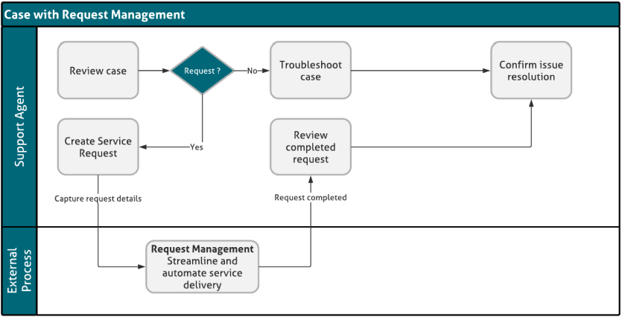

Img-4.3.1

• Create one or more requests on behalf of a customer from an existing customer service case

. • Associate an existing request to a case.

• Remove an associated request from a case.

• View a list of requests associated with a case in the Requests related list.

• View the following in the case work notes: o Request state changes. o Additional comments added to the request record.

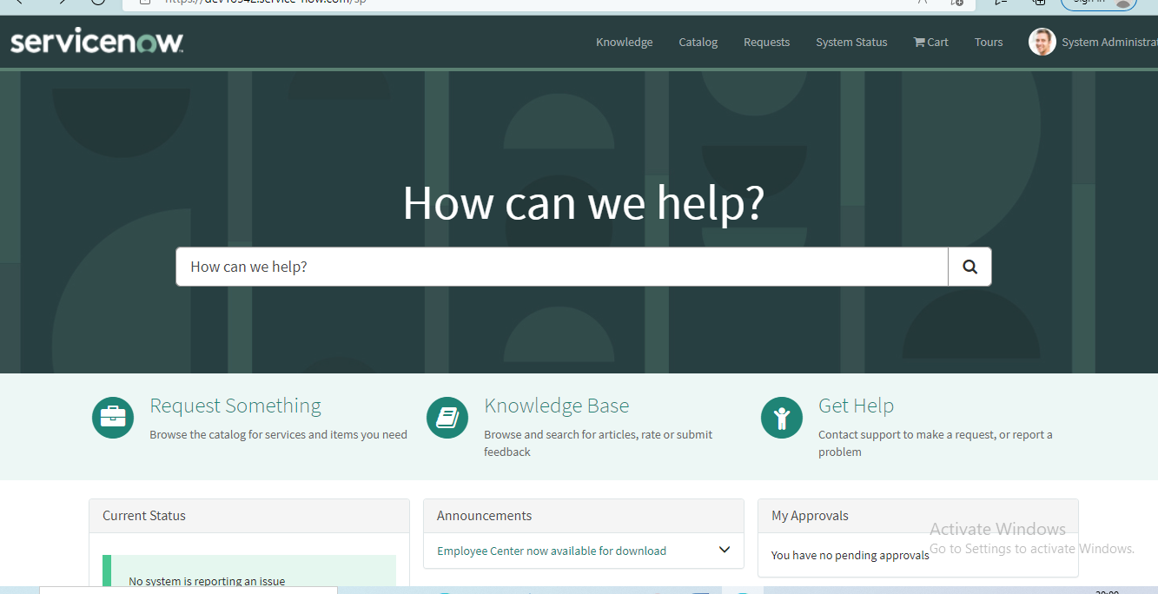

**4.4Personal Developer Instance(PDI)**

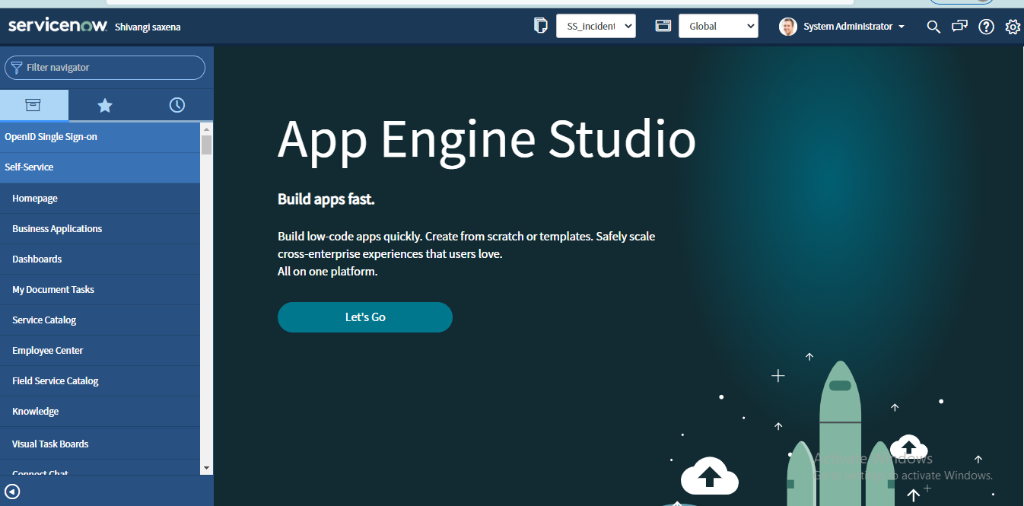

Img-4.4.1

**4.5 App Menu:**

The Application Menu is composed of a drop-down button control that displays a menu containing Commands that expose functionality related to a complete project, such as an entire document, picture, or movie.

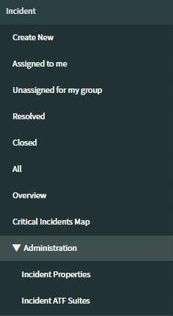

Img-4.5.1

Incident form layout should be like this:

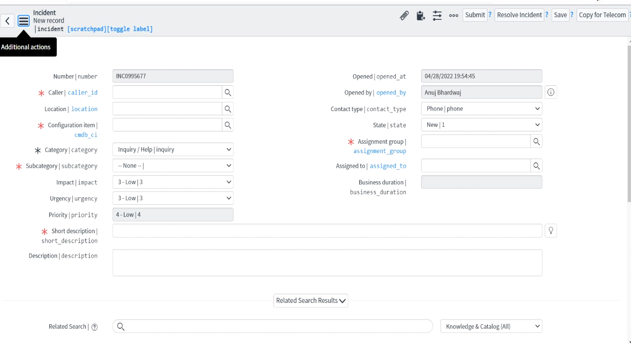 img-4.5.2

The fields which are highlighted in the figure are custom fields:

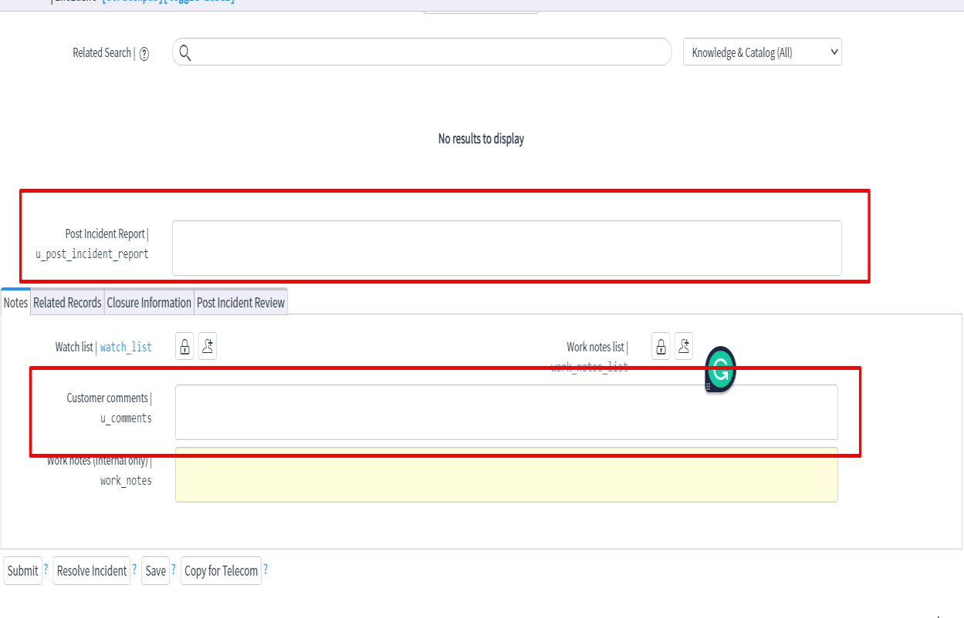

Img-4.5.3

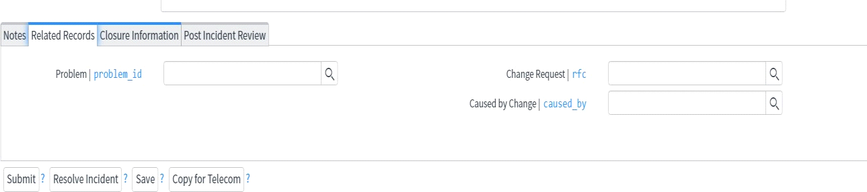img-4.5.4

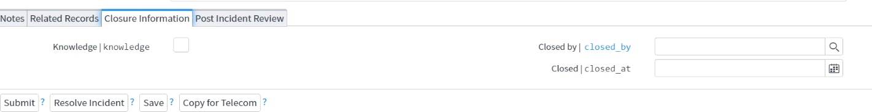img-4.5.5

**Caller Field:**

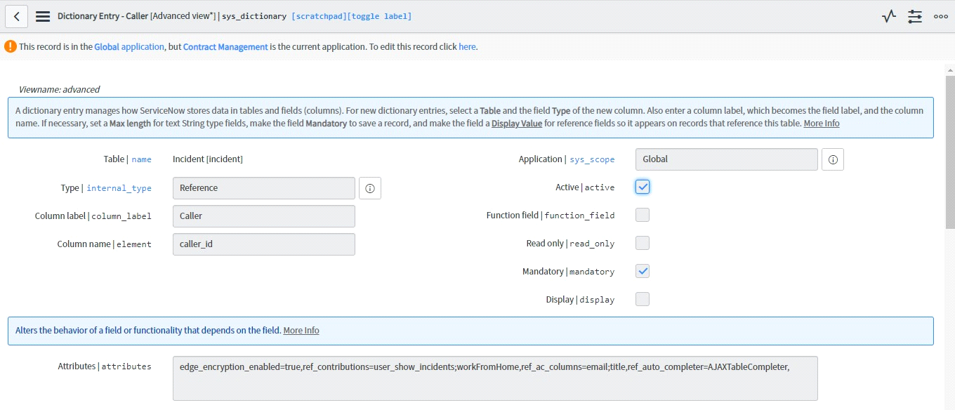

Img-4.5.6

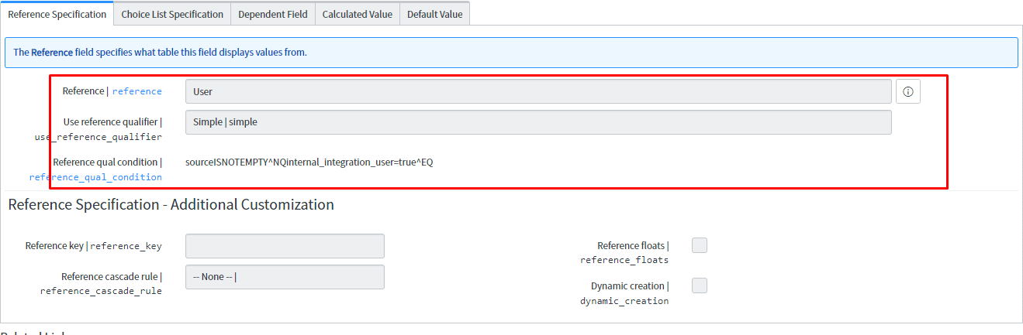

**Img-4.5.7CHAPTER 5**

**Configuration Item**

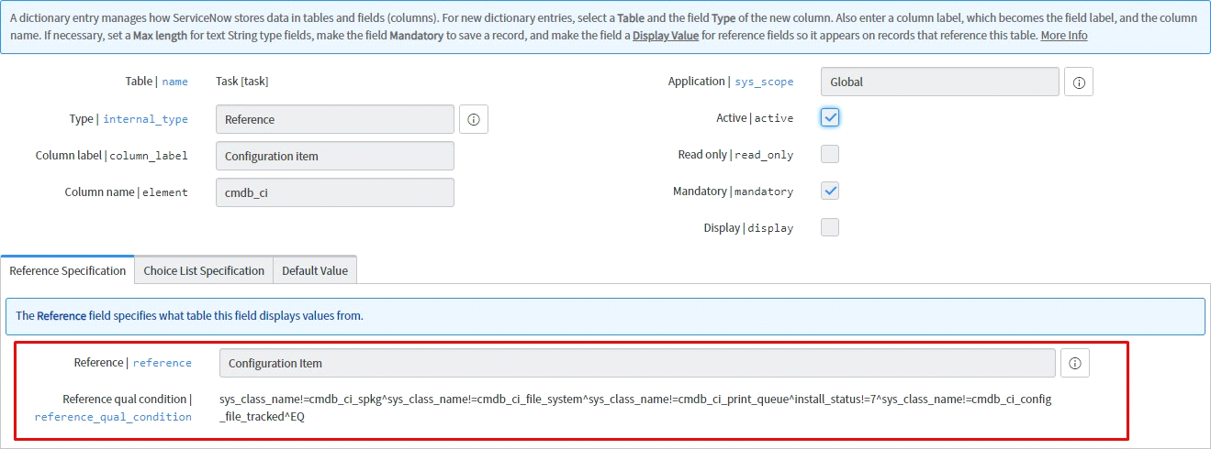

Img-5.1

**Category:**

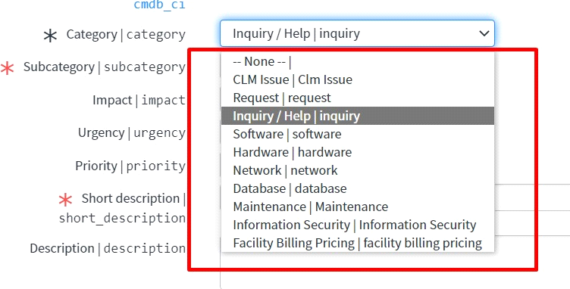

**Img-5.2**

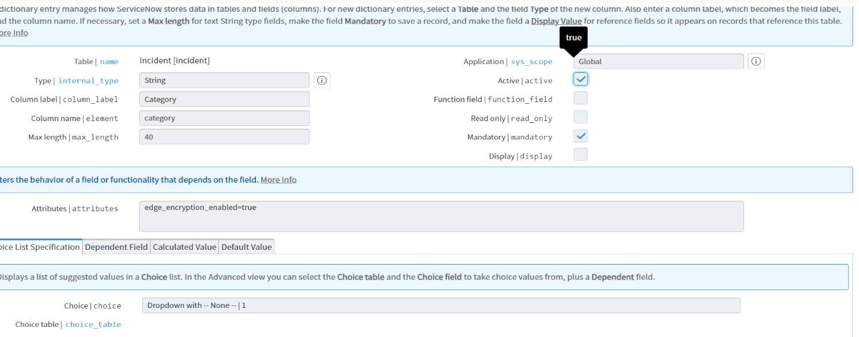img-5.3

**Subcategory:**

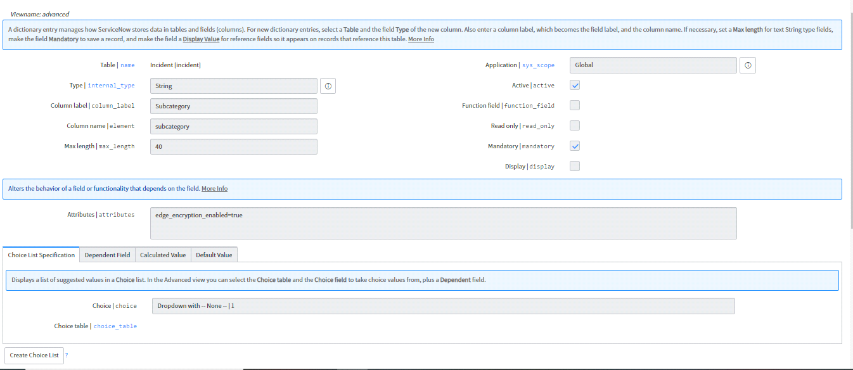img-5.4

**Impact, Urgency, Priority:**

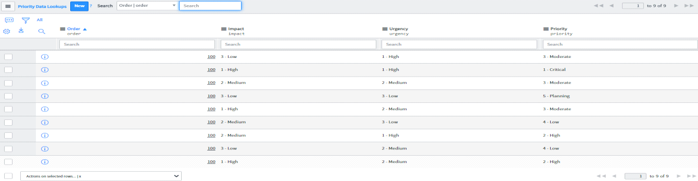

**Img-5.5**

**CHAPTER 6**

**User Interface Policies**

**UI Policy for Priority:**

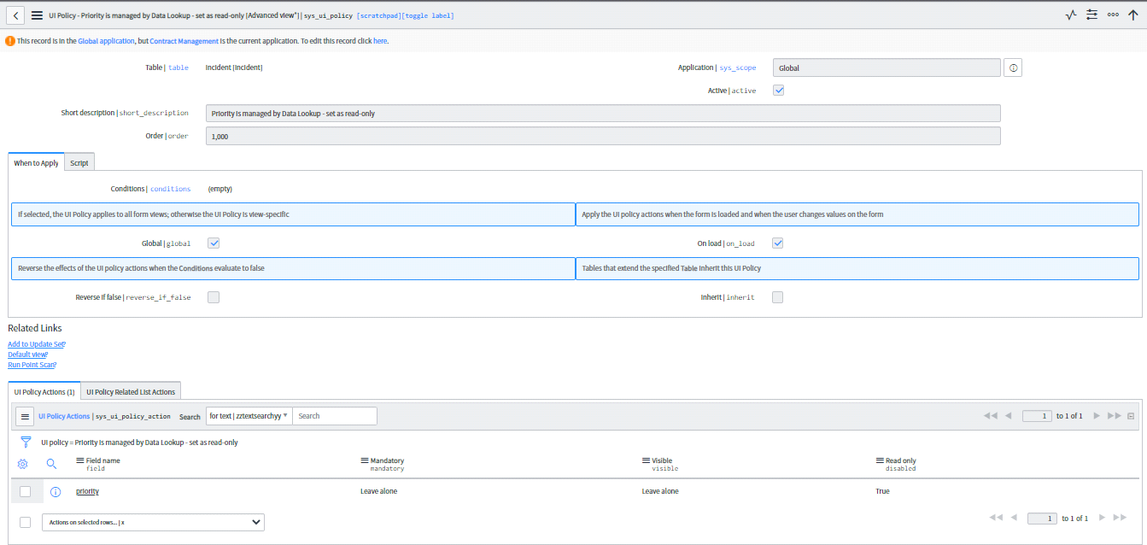img-6.1

**Short Description:**

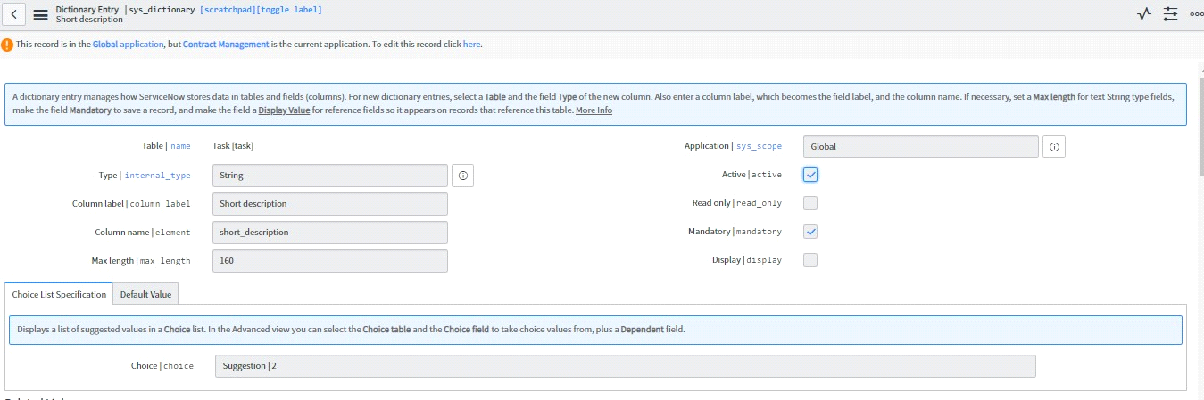img-6.2

**Opened:**

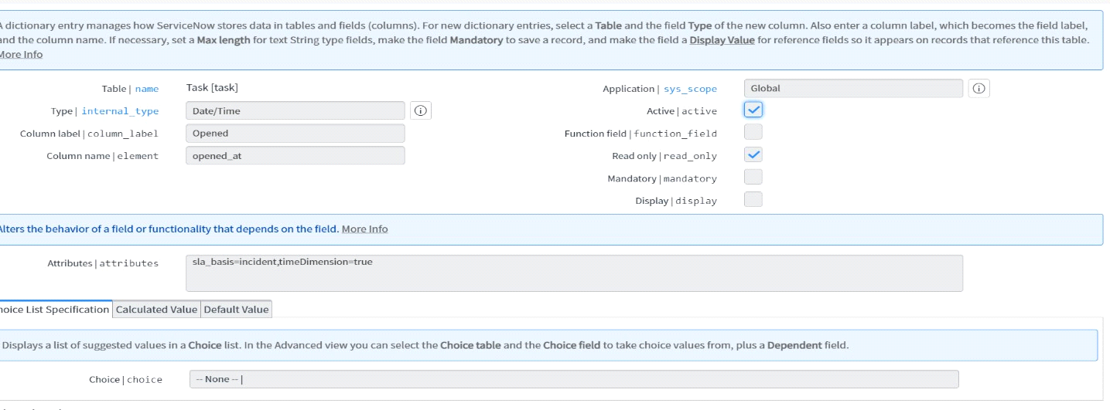img-6.3

**Opened By:**

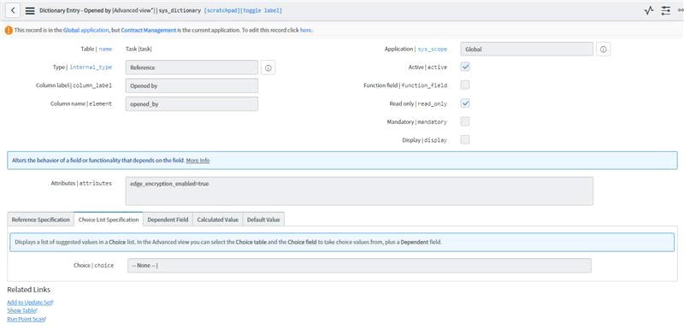img-6.4

**Contact Type:**

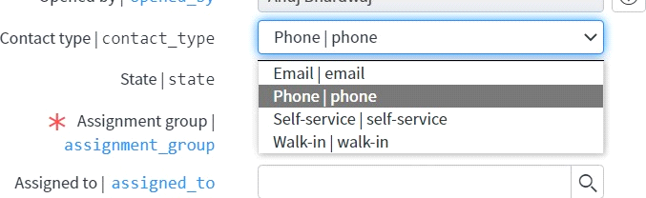

Img-6.5

**Assignment Group:**

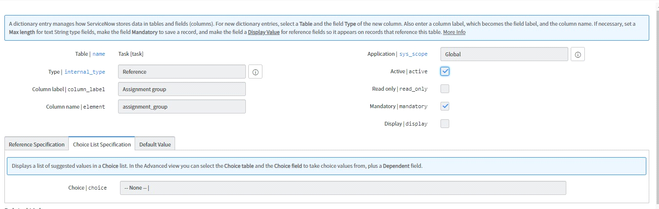

Img-6.6

**Business Duration:**

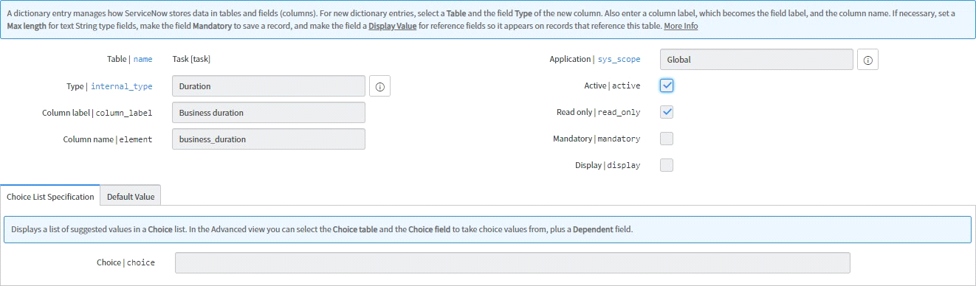img-6.7

**State:**

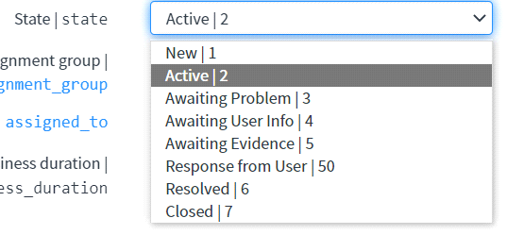

Img-6.8

**CHAPTER 7**

**User Interface Actions**

**UI Actions:**

UI Actions are UI elements that can show up on a form or a list as a button, link, or context menu. When these UI elements are clicked they execute some JavaScript. Most of the time UI Actions are used to perform some server-side update to a record or records.

UI actions can be configured to run either server side, or client side. It is also possible to configure a UI Action to run some code on the client, and other code on the server.

**Resolve Incident:**

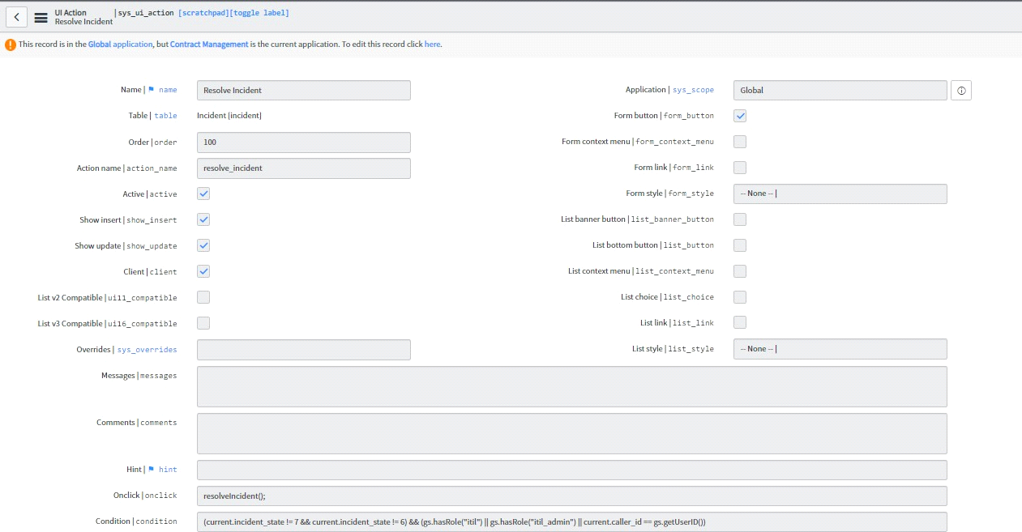img-7.1

function resolveIncident(){

//Set the 'Incident state' and 'State' values to 'Resolved', and display mandatory fields g_form.setValue('incident_state', 6);

g_form.setValue('state', 6);

//Call the UI Action and skip the 'onclick' function

gsftSubmit(null, g_form.getFormElement(), 'resolve_incident'); //MUST call the 'Action name' set in this UI Action

}

// Original Code End

//Code that runs without 'onclick'

//Ensure call to server-side function with no browser errors

if (typeof window == 'undefined') serverResolve();

function serverResolve(){ current.incident_state = 6; current.update();

}

**Copy for Telecom:**

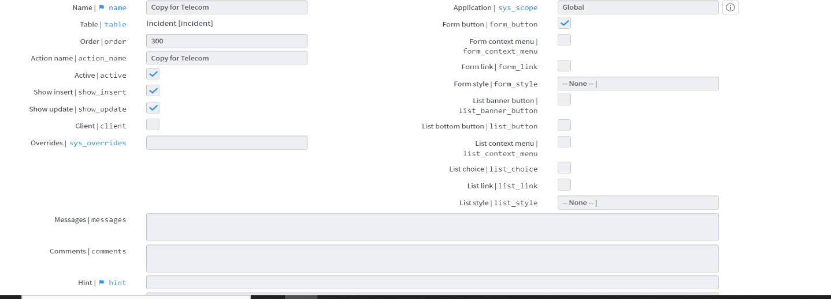

Img-7.2

var inc = new GlideRecord("incident"); inc.contact_type = current.contact_type;

//inc.u_source = "Proactive"; inc.caller_id = current.caller_id;

//inc.u_user_id = current.u_user_id; inc.location = current.location;

//inc.cmdb_ci = current.cmdb_ci; inc.cmdb_ci.setDisplayValue('Mobile Phone');

//inc.u_application = current.u_application;

//inc.assignment_group = current.assignment_group; inc.assignment_group.setDisplayValue('Telecomm Support');

inc.assigned_to = 'Brian Wannemacher'; inc.short_description = current.short_description;

inc.description = "Incident duplicated from " + current.number + " for Telecomm use.\n\n" + current.description;

inc.comments = "Incident duplicated from " + current.number + " for Telecomm use."; inc.category = "hardware";

inc.subcategory = "Purchase"; inc.impact = current.impact; inc.urgency = current.urgency; inc.insert();

//Copy any attachments from the incident record to the request record

//Packages.com.glide.ui.SysAttachment.copy("incident", current.sys_id, "incident", inc.sys_id);

//update existing Incident record

current.work_notes = "This incident has been duplicated to " + inc.number + " for Telcom purposes."; current.update();

//provide onscreen feedback and set URLs

gs.addInfoMessage("Incident " + inc.number + " duplicated from " + current.number); action.setRedirectURL(inc);

action.setReturnURL(current);

**CHAPTER 8**

**Configuration Items**

**Flash CI Information:**

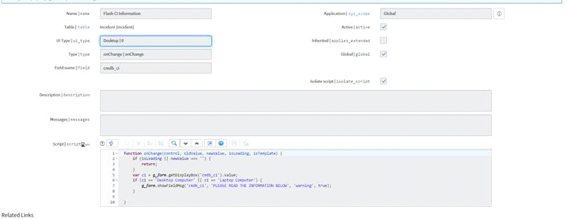img-8.1

***Script:***

function onChange(control, oldValue, newValue, isLoading, isTemplate) { if (isLoading || newValue === '') {

return;

}

var ci = g_form.getDisplayBox('cmdb_ci').value;

if (ci == 'Desktop Computer' || ci == 'Laptop Computer') {

g_form.showFieldMsg('cmdb_ci', 'PLEASE READ THE INFORMATION BELOW', 'warning', true);

}

}

**Create Child Incident:**

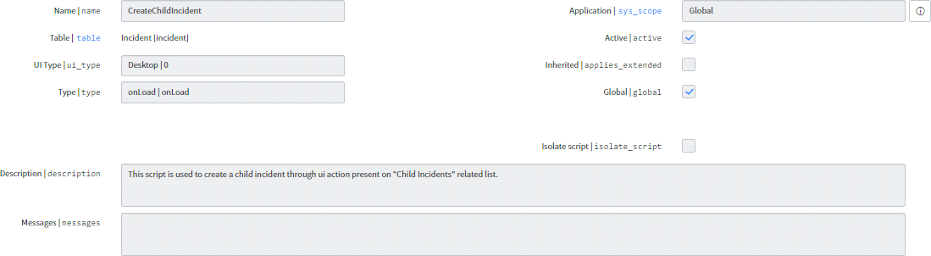

Img-8.2

Script:

function onLoad() {

NOW._createChildIncident = function(srcSysId){ var ga = new GlideAjax('IncidentUtils2');

ga.addParam('sysparm_name', 'getIncidentQueryParams'); ga.addParam('sysparm_src_sysid', srcSysId); ga.addParam('sysparm_ui_action', "create_child_incident"); ga.setWantSessionMessages(true); ga.getXMLAnswer(function(queryParam){

if (queryParam) { var ck;

if (typeof g_ck != 'undefined' && g_ck != "") ck = g_ck;

var gotoUrl = []; gotoUrl.push('srcSysID=' + srcSysId); gotoUrl.push('newSysID=$sys_id');

gotoUrl.push('sysparm_returned_action=$action'); if (ck)

gotoUrl.push('sysparm_ck=' + ck);

gotoUrl = 'CopyIncidentRelatedLists.do?' + gotoUrl.join('&');

var form = cel('form', document.body); hide(form);

form.method = "POST"; form.action = "incident.do"; if (ck)

_addParam(form, 'sysparm_ck', g_ck);

_addParam(form, 'sys_id', '-1');

_addParam(form, 'sysparm_query', queryParam);

_addParam(form, 'sysparm_goto_url', gotoUrl); form.submit();

}else{

g_form.addErrorMessage("Failed to create child incident");

}

});

};

function _addParam(form, name, val) { var inp = cel('textarea', form); inp.name = name;

inp.value = val;

}

}

Note:

Create a Child Incident Script Include.

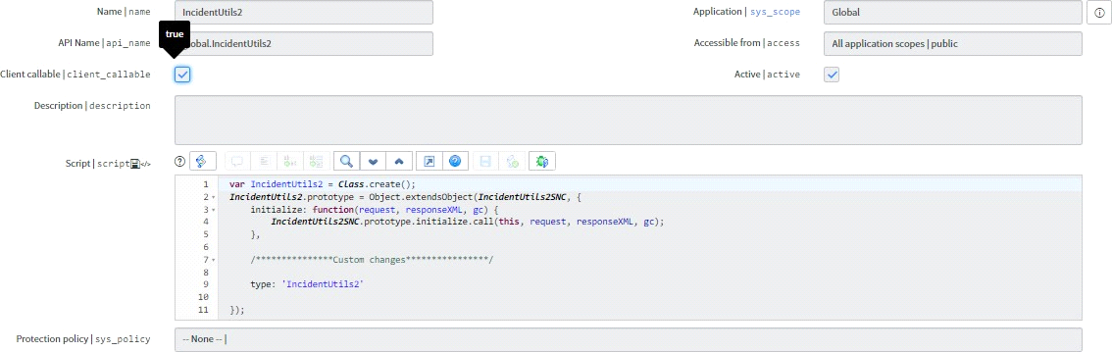

Img-8.3

***Script:***

var IncidentUtils2 = Class.create();

IncidentUtils2.prototype = Object.extendsObject(IncidentUtils2SNC, { initialize: function(request, responseXML, gc) {

IncidentUtils2SNC.prototype.initialize.call(this, request, responseXML, gc);

},

/***************Custom changes****************/

type: 'IncidentUtils2'

});

**CHAPTER 9**

CLIENT SCRIPTS:

Client Script means scripts (java script) which runs on client side or on client browser.

Client Scripts come in four basic types: onLoad , onChange , onSubmit , and onCellEdit . Each type runs under different conditions, and often has a different use than the others.

**Show Replacement Popup:**

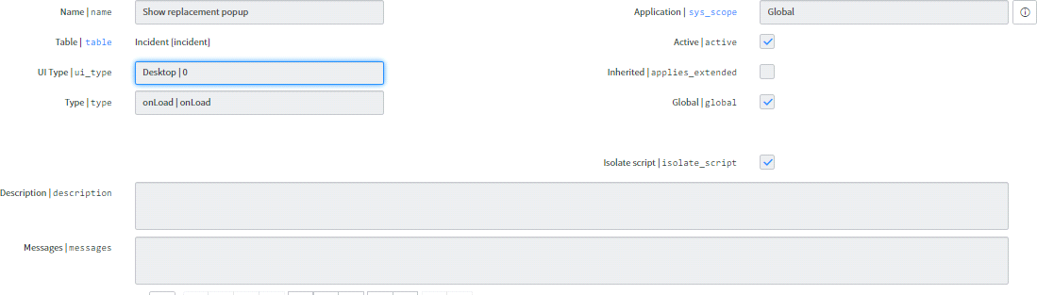img-9.1

function onLoad() {

var code = g_form.getValue('close_code');

var ritm = g_form.getValue('u_requested_item').toString() || ""; var state = parseInt(g_form.getValue('state'));

if (code == "Submit replacement request" && ritm == "" && state >= 6) g_form.getReference('cmdb_ci', createPopup);

function createPopup(ci) {

var caller = g_form.getValue('caller_id').toString(), incident = g_form.getUniqueValue();

var ga = new GlideAjax('clientTableScripts'); ga.addParam('sysparm_name', 'findRecord'); ga.addParam('sysparm_table', 'sc_req_item');

ga.addParam('sysparm_query', 'variables.fb493150dbb45c1034477a131f961980!=NULL^variables.fb493150dbb45c1034477a131f96198 0=' + ci.serial_number.toString() + '^stateNOT IN3,4,7');

ga.getXMLAnswer(checkOpenReplacements);

function checkOpenReplacements(answer) { if(answer === null) {

if(ci.sys_class_name == 'cmdb_ci_computer' || ci.name == 'Laptop computer' || ci.name == 'Desktop Computer') {

createDialogWindow( 'ComputerReplacementRequest', 'Create Request',

{ 'sysid': incident, 'caller': caller, 'model': ci.model_id, 'serial': ci.serial_number, 'tag': ci.asset_tag, 'assetname': ci.name }

);

}

else { createDialogWindow(

'EquipmentReplacementRequest', 'Create Request',

{ 'sysid': incident, 'caller': caller }

);

}

} else

var ritm = JSON.parse(answer); createDialogWindow( 'ComputerReplacementRequestAlreadyExists', 'Request Already Exists',

{ 'sysid': ritm.sys_id, 'number': ritm.number }

);

}

}

}

}

function createDialogWindow(ui_page, title, preferences) { var gdw = new GlideDialogWindow(ui_page); gdw.setTitle(title);

for(var p in preferences) gdw.setPreference(p, preferences[p]); gdw.setSize(500, 200);

gdw.render();

}

**Modify Work Notes Label:**

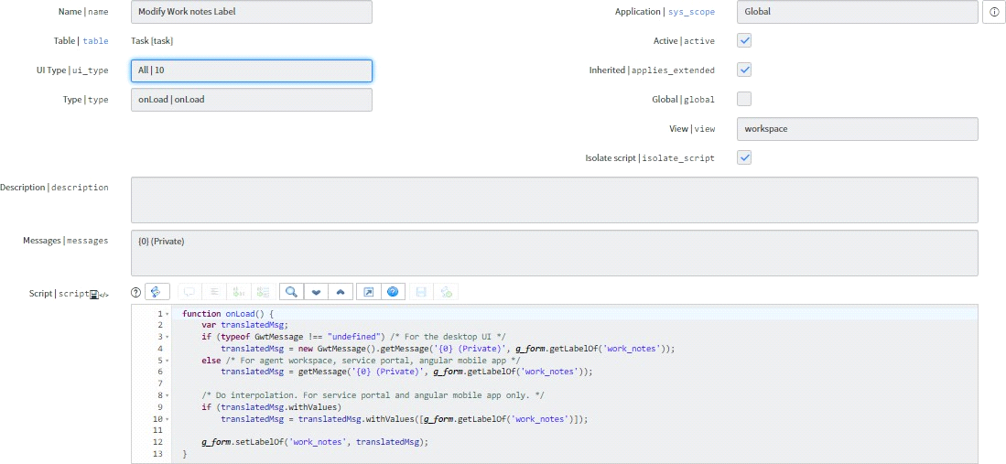

Img-9.2

***Script:***

if (typeof GwtMessage !== "undefined") /* For the desktop UI */

translatedMsg = new GwtMessage().getMessage('{0} (Private)', g_form.getLabelOf('work_notes')); else /* For agent workspace, service portal, angular mobile app */

translatedMsg = getMessage('{0} (Private)', g_form.getLabelOf('work_notes'));

/* Do interpolation. For service portal and angular mobile app only. */ if (translatedMsg.withValues)

translatedMsg = translatedMsg.withValues([g_form.getLabelOf('work_notes')]);

g_form.setLabelOf('work_notes', translatedMsg);

}

Set Review Trigger Fields:

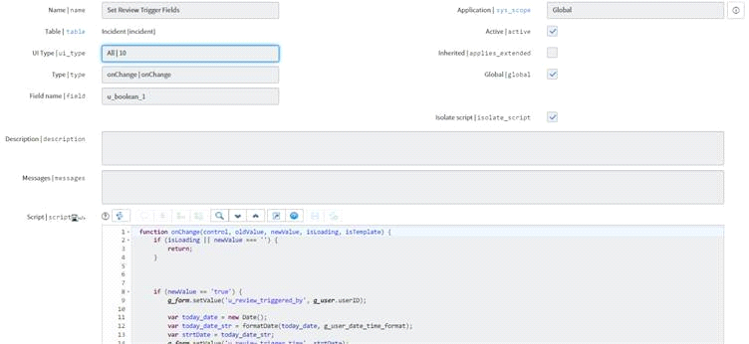

Img-9.3

function onChange(control, oldValue, newValue, isLoading, isTemplate) { if (isLoading || newValue === '') {

return;

}

if (newValue == 'true') { g_form.setValue('u_review_triggered_by', g_user.userID);

var today_date = new Date();

var today_date_str = formatDate(today_date, g_user_date_time_format); var strtDate = today_date_str;

g_form.setValue('u_review_trigger_time', strtDate);

} else {

g_form.clearValue('u_review_triggered_by'); g_form.clearValue('u_review_trigger_time');

}

}

(BP) Hide Choice – Closed:

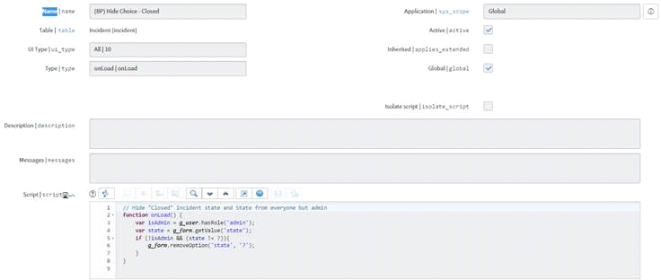

Img-9.4

***Script:***

// Hide "Closed" Incident state and State from everyone but admin function onLoad() {

var isAdmin = g_user.hasRole('admin'); var state = g_form.getValue('state');

if (!isAdmin && (state != 7)){ g_form.removeOption('state', '7');

}

}

(BP) Hide Attachment Link when Closed:

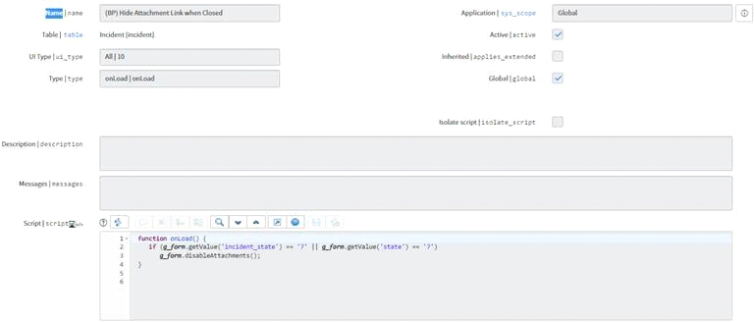img-9.5

function onLoad() {

if (g_form.getValue('incident_state') == '7' || g_form.getValue('state') == '7') g_form.disableAttachments();

}

**Warranty expiration alert:**

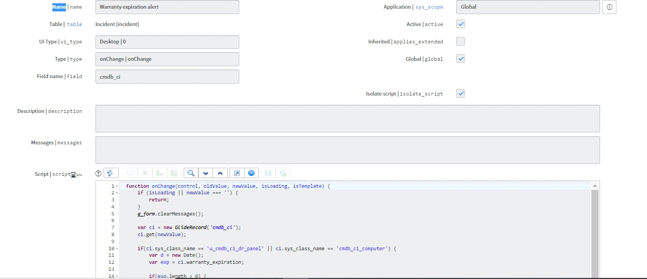

Img-9.6

function onChange(control, oldValue, newValue, isLoading, isTemplate) { if (isLoading || newValue === '') {

return;

}

g_form.clearMessages();

var ci = new GlideRecord('cmdb_ci'); ci.get(newValue);

if(ci.sys_class_name == 'u_cmdb_ci_dr_panel' || ci.sys_class_name == 'cmdb_ci_computer') { var d = new Date();

var exp = ci.warranty_expiration;

if(exp.length > 0) {

var year = d.getFullYear(); var month = d.getMonth(); var day = d.getDate();

var warr_year = exp.slice(0, 4); var warr_month = exp.slice(5, 7); var warr_day = exp.slice(8, 10);

if(warr_year < year) {

g_form.addErrorMessage(ci.name + " is out of warranty (expired " + exp + ")");

}

else if(warr_year == year) {

if(warr_month < month) {

g_form.addErrorMessage(ci.name + " is out of warranty (expired " + exp + ")");

}

else if(warr_month == month) { if(warr_day < day)

g_form.addErrorMessage(ci.name + " is out of warranty (expired " + exp + ")"); else

g_form.addInfoMessage(ci.name + ' warranty expiration: ' + exp);

}

else

g_form.addInfoMessage(ci.name + ' warranty expiration: ' + exp);

}

else

g_form.addInfoMessage(ci.name + ' warranty expiration: ' + exp);

}

else

g_form.addInfoMessage(ci.name + " is missing warranty information.");

}

}

(BP) Close Mandatory on Close or Resolve**:**

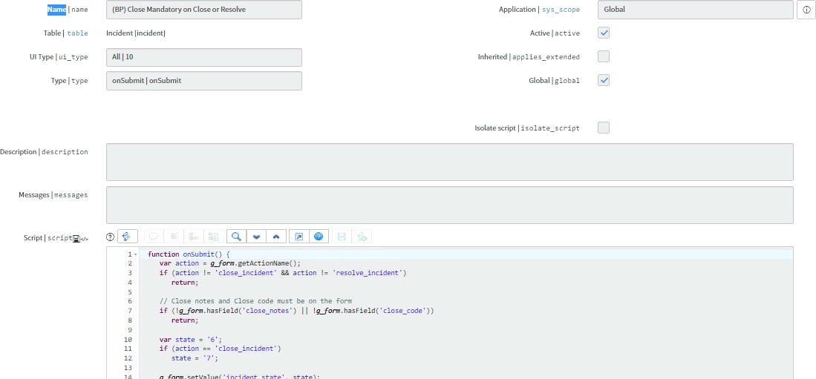img-9.7

function onSubmit() {

var action = g_form.getActionName();

if (action != 'close_incident' && action != 'resolve_incident') return;

// Close notes and Close code must be on the form

if (!g_form.hasField('close_notes') || !g_form.hasField('close_code')) return;

var state = '6';

if (action == 'close_incident') state = '7';

g_form.setValue('incident_state', state); g_form.setValue('state', state); g_form.setDisplay('close_notes', true); g_form.setMandatory('close_notes', true);

g_form.setDisplay('close_code', true); g_form.setMandatory('close_code', true);

if (g_form.getValue('close_notes') == '' || g_form.getValue('close_code') == '') return false;

}

**(BP) Hide Close Notes and Code:**

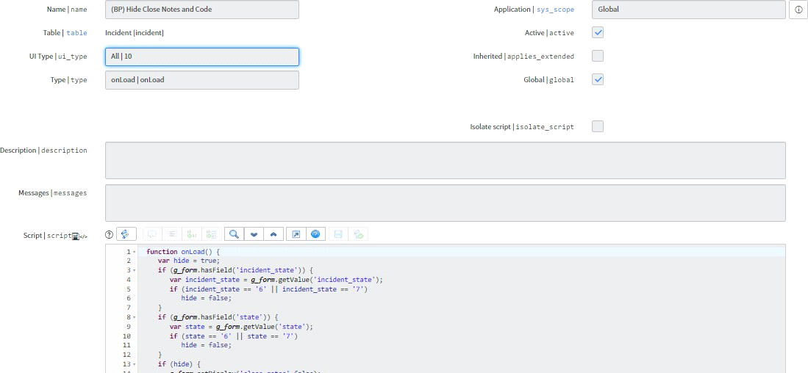img-9.8

function onLoad() { var hide = true;

if (g_form.hasField('incident_state')) {

var incident_state = g_form.getValue('incident_state'); if (incident_state == '6' || incident_state == '7')

hide = false;

}

if (g_form.hasField('state')) {

var state = g_form.getValue('state');

if (state == '6' || state == '7') hide = false;

}

if (hide) { g_form.setDisplay('close_notes',false); g_form.setDisplay('close_code',false);

} else { g_form.setDisplay('close_notes',true); g_form.setMandatory('close_notes',true); g_form.setDisplay('close_code',true); g_form.setMandatory('close_code',true);

}

}

**Transfer Popup:**

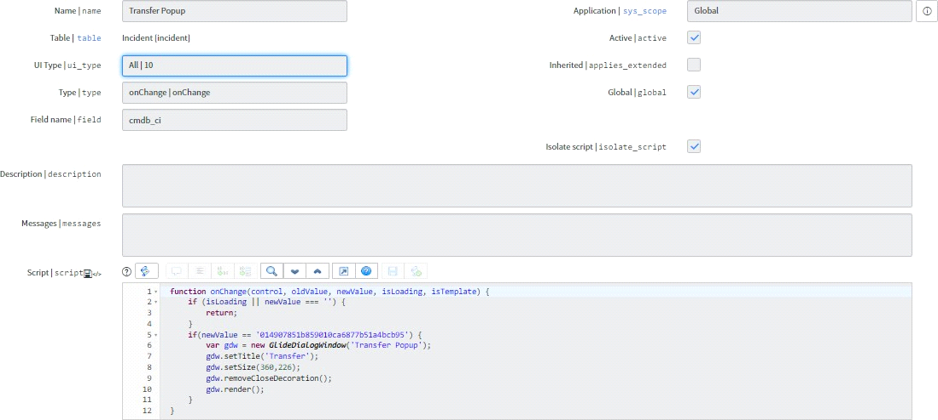

Img-9.9

function onChange(control, oldValue, newValue, isLoading, isTemplate) { if (isLoading || newValue === '') {

}

if(newValue == '014907851b859010ca6877b51a4bcb95') { var gdw = new GlideDialogWindow('Transfer Popup'); gdw.setTitle('Transfer');

gdw.setSize(360,226); gdw.removeCloseDecoration(); gdw.render();

}

}

**Modify Comments Label:**

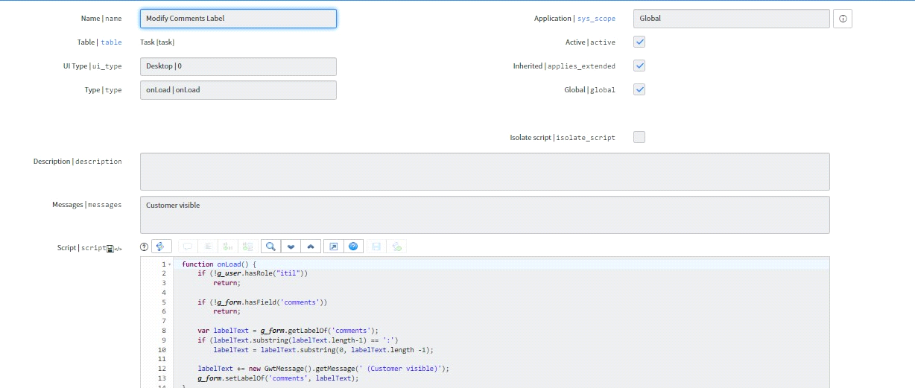

Img-9.10

function onLoad() {

if (!g_user.hasRole("itil")) return;

if (!g_form.hasField('comments'))

var labelText = g_form.getLabelOf('comments'); if (labelText.substring(labelText.length-1) == ':')

labelText = labelText.substring(0, labelText.length -1);

labelText += new GwtMessage().getMessage(' (Customer visible)'); g_form.setLabelOf('comments', labelText);

}

**Highlight VIP Caller:**

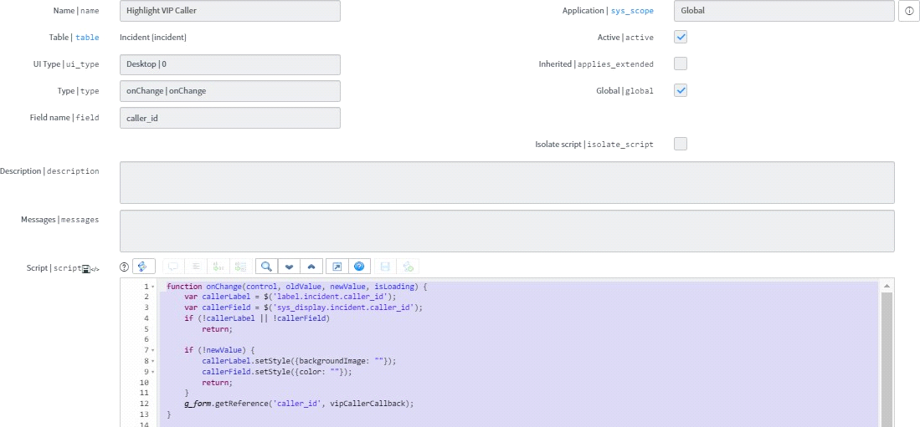img-9.11

function onChange(control, oldValue, newValue, isLoading) { var callerLabel = $('label.incident.caller_id');

var callerField = $('sys_display.incident.caller_id'); if (!callerLabel || !callerField)

return;

if (!newValue) { callerLabel.setStyle({backgroundImage: ""});

callerField.setStyle({color: ""}); return;

}

g_form.getReference('caller_id', vipCallerCallback);

}

function vipCallerCallback(caller) {

var callerLabel = $('label.incident.caller_id').down('label'); var callerField = $('sys_display.incident.caller_id');

if (!callerLabel || !callerField) return;

{

var bgPosition = "95% 55%";

if (document.documentElement.getAttribute('data-doctype') == 'true') bgPosition = "5% 45%";

callerLabel.setStyle({backgroundImage: "url(images/icons/vip.gif)", backgroundRepeat: "no-repeat", backgroundPosition: bgPosition, paddingLeft: '30px' });

callerField.setStyle({color: "red"});

} else { callerLabel.setStyle({backgroundImage: ""}); callerField.setStyle({color: ""});

}

}

**Highlight VIP Caller (Smartphone):**

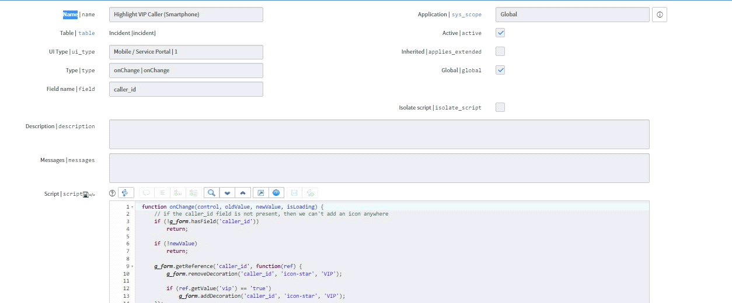

Img-9.12

function onChange(control, oldValue, newValue, isLoading) {

// if the caller_id field is not present, then we can't add an icon anywhere if (!g_form.hasField('caller_id'))

return;

if (!newValue) return;

g_form.getReference('caller_id', function(ref) { g_form.removeDecoration('caller_id', 'icon-star', 'VIP');

if (ref.getValue('vip') == 'true') g_form.addDecoration('caller_id', 'icon-star', 'VIP');

});

}

**Image Routing Popup:**

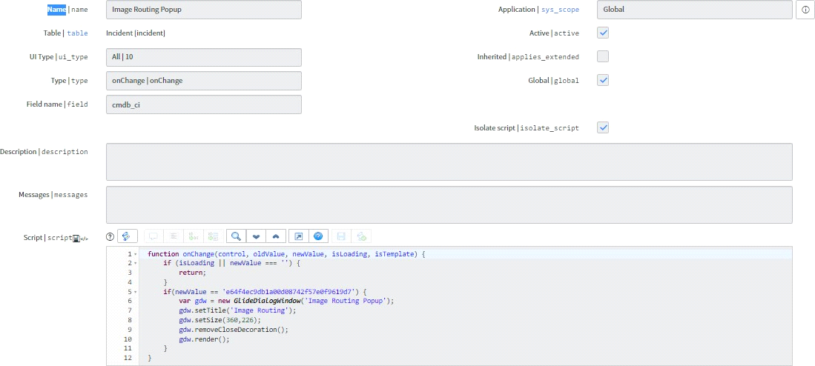img-9.13

function onChange(control, oldValue, newValue, isLoading, isTemplate) { if (isLoading || newValue === '') {

return;

}

if(newValue == 'e64f4ec9db1a00d08742f57e0f9619d7') { var gdw = new GlideDialogWindow('Image Routing Popup'); gdw.setTitle('Image Routing');

gdw.setSize(360,226); gdw.removeCloseDecoration(); gdw.render();

}

}

**CHAPTER 10**

**Business Rules**

**Business rule**

Business rules is the server side script which means that it will execute on server or database. Business rule runs faster than other script in ServiceNow. The script or code written in business rule area will get executed when record is inserted, displayed, updated, deleted or when table is queried.

The four types of business rule in ServiceNow are:

* Display Business Rule
* Before Business Rule
* After Business Rule
* Async Business Rule

**10.1Display Business Rule in ServiceNow:**

Code written in display business rule get executed before the form is presented to the user and just after the data is read from the database.

For e.g. you have written the code that when xyz user click on information box then only data related to that user specific country will get displayed to user. It means that user from US can see US specific data and user from India can see India specific data.

**10.2 Before Business Rule in ServiceNow:**

Code written in before business rule get executed when user submits the form and data is not saved in database. Let’s say User click on submit button --> Before business rule code executes --> information will save in database.

For e.g. Let’s say you have written the code that when user click on submit button then some extra information which in not filled by user such as user current location, user manager name and user past activities will get save when user click on submit button.

**10.3After Business Rule in ServiceNow:**

Code written in after business rule get executed when user submits the form and data saved in database.

Let’s say User click on submit button --> data saved in database --> Now after business rule code get executed.

For e.g. there is parent incident and child incident and you want that related child incident will get closed automatically after the parent incident get closed by user.

**10.4Async Business Rule in ServiceNow:**

Async business rules are like after business rule but it runs in the background simultaneously with other processes. Means async business rule run after the data is saved into the database.

Running on background means that use can proceed with other functionality and code will run on the background which will not impact the user while doing other transitions.

For e.g. Incident ticket is in pending customer action status and will be auto closed after 5 days if user did not provide any update on incident ticket.

**10.5Abort Assignment if CI is Empty:**

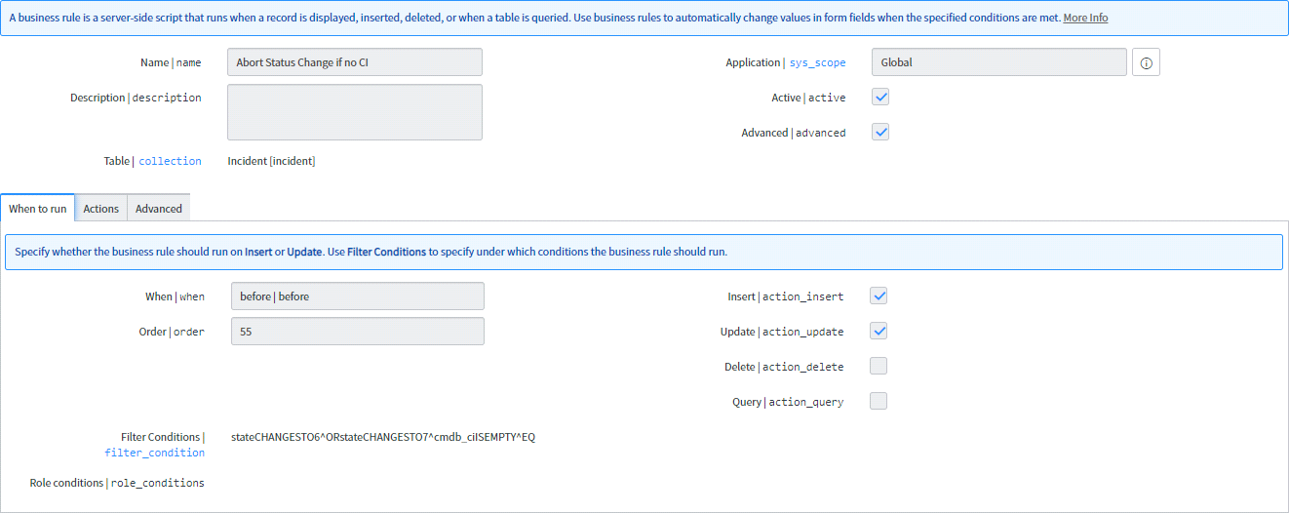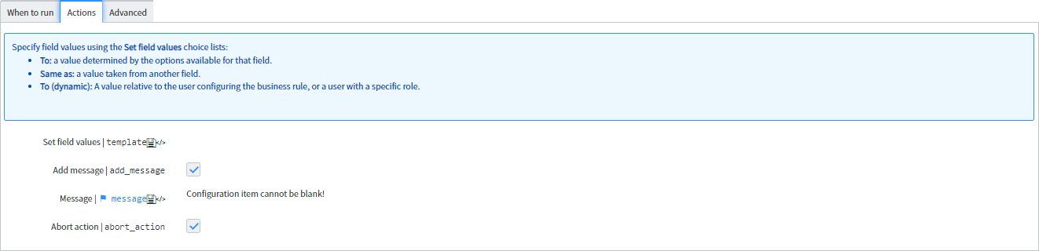img-10.1

Add manager to watchlist:

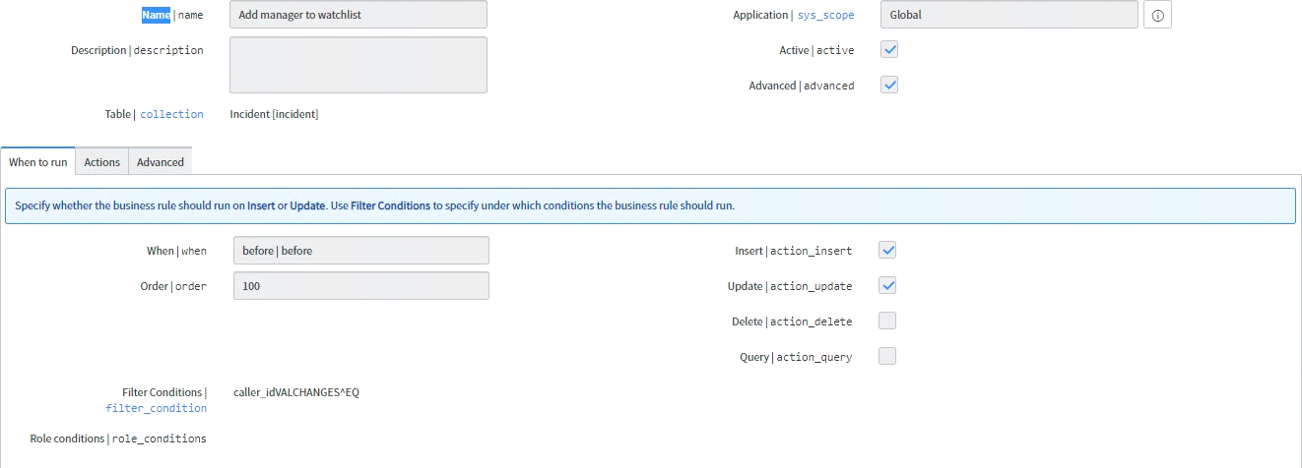

Img-10.2

Script:

(function executeRule(current, previous /*null when async*/) {

var wla = current.watch_list.toString().split(","); //array containing watch_list members var mgr = current.caller_id.manager;

var caller = current.caller_id.title; var i;

var chk = 0; //0= false, 1= true

//Loop through the watchlist to see if the user's manager is already a member

for (i = 0; i < wla.length; i++) {

if (wla[i] == mgr) { chk = 1;

break;

}

}

//If the watchlist is empty, add the manager.

//If the watchlist is not empty, and does contain the manager as a member, add the manager.

//Display a message indicating who was added to the watchlist

if (caller.indexOf('Ultrasound Specialist') > -1 || caller.indexOf('Ultrasound Tech') > -1 || caller.indexOf('Radiologic Technologist') > -1) {

if (current.watch_list == "") { current.watch_list+= mgr;

gs.addInfoMessage(mgr.getDisplayValue() + " has been added to the watchlist");

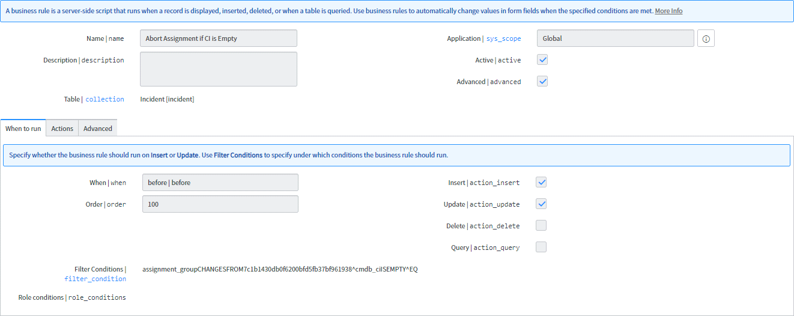img-10.3

**Multiple tickets notification:**

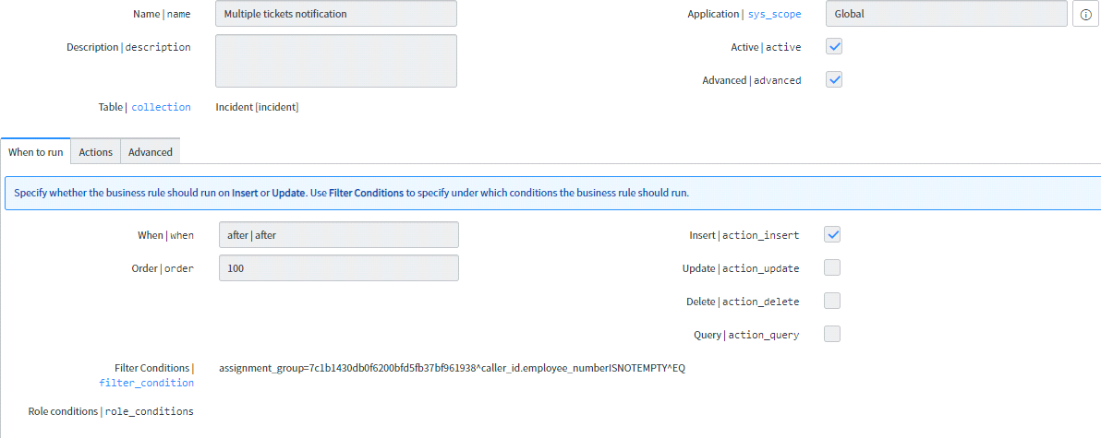img-10.4

**Script:**

(function executeRule(current, previous /*null when async*/) {

var inc = new GlideRecord('incident');

inc.addEncodedQuery('opened_atONToday@javascript:gs.beginningOfToday()@javascript:gs.endOfTod ay()^caller_idLIKE'+current.caller_id.name+'^assignment_group=7c1b1430db0f6200bfd5fb37bf961938')

;

inc.query();

var incidents = inc.getRowCount(); if(inc.getRowCount() > 1) {

gs.eventQueue('incident.second.today', current, String(incidents), gs.getUserName());

}

})(current, previous);

**Prevent close from list view:**

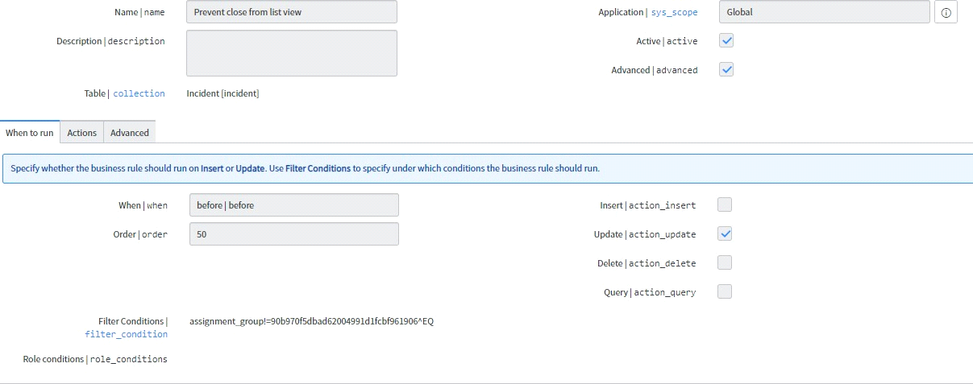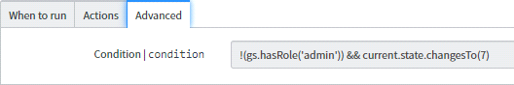img-10.5

**Response from User:**

**State is resolved /comments/close_notes:**

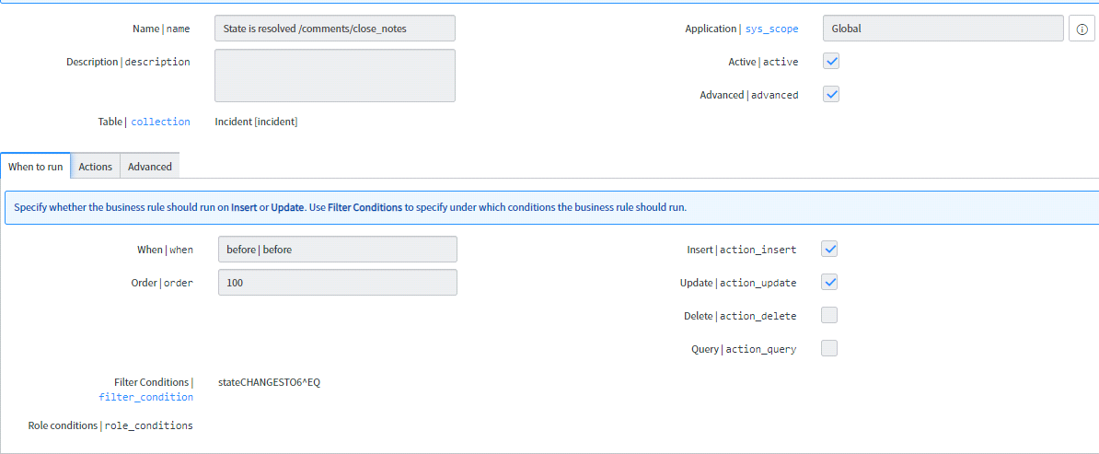

Img-10.6

**Prevent close from list view:**



Img-10.7

**Response from User:**

**State is resolved /comments/close_notes:**



**script:**

(function executeRule(current, previous /*null when async*/) {

if(current.close_notes.length == 0) {

var text = current.getValue('u_comments'); current.setValue('close_notes', text);

}

current.work_notes = 'Close notes: \n' + current.getValue('close_notes');

})(current, previous);

**Change state on closed Insert:**

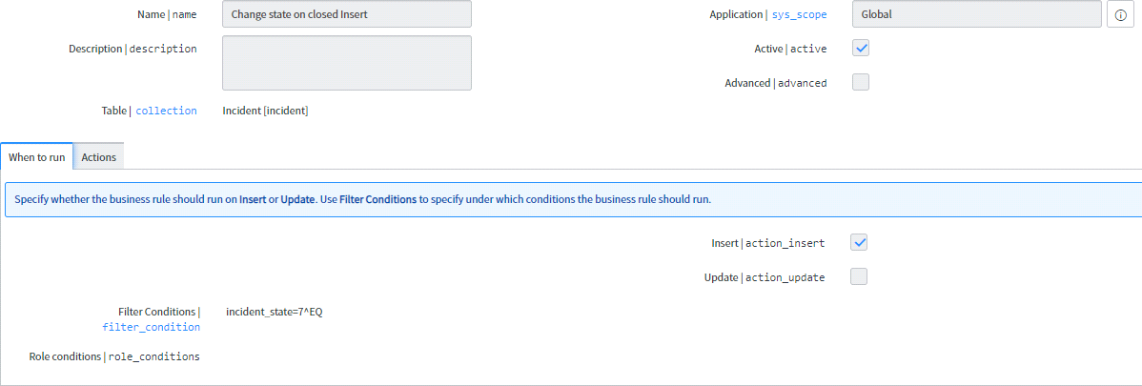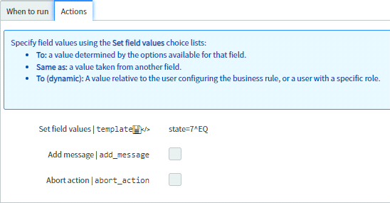10.7

**Notifications:**

**Template: *Please use this type of template in every notification.**

<p></p>

<table style="height: 361px; border-color: #bcd9f0; width: 100%;" border="1">

<tbody>

<tr style="height: 100px;">

<td style="text-align: center; background-color: #bcd9f0; width: 97.5177%; height: 100px;" colspan="2">&nbsp;&nbsp;<img title="" src="TridentCare%20Email%20Signature%20Logo.pngx" alt="" width="250" height="60" align="baseline" border="" hspace="" vspace="" /></td>

</tr>

<tr style="height: 27px;">

<td style="text-align: left; width: 97.5177%; height: 27px;" colspan="2"><span style="font-size: 10pt;">${parent.number} is approved and enterprise ID created, set up billing configuration.

${parent.client_name.name}(${parent.client_name.corporate_code})<br /><br /></span></td>

</tr>

<tr style="height: 27px;">

<td style="width: 33.2151%; height: 27px;"><span style="font-size: 13.3333px;"><strong>Number</strong></span></td>

<td style="width: 64.3026%; height: 27px;"><span style="font-size: 10pt;">${number}<br

/></span></td>

</tr>

<tr style="height: 27px;">

<td style="width: 33.2151%; height: 44px;"><span style="font-size: 10pt;"><strong>Client Name</strong></span></td>

<td style="width: 64.3026%; height: 44px;"><span style="font-size: 10pt;">${parent.client_name.name}</span></td>

</tr>

<tr style="height: 16px;">

<td style="width: 33.2151%; height: 16px;"><span style="font-size: 10pt;"><strong>PACC Record</strong></span></td>

<td style="width: 64.3026%; height: 16px;"><span style="font-size: 10pt;"><a title="${pacc_number.number}" href="/x_tusah_contract_m_client_demographic.do?sys_id=${parent}">${parent}</a><br

/></span></td>

</tr>

<tr style="height: 27px;">

<td style="width: 33.2151%; height: 27px;"><strong><span style="font-size: 10pt;">Client Billing Type</span></strong></td>

<td style="width: 64.3026%; height: 27px;"><span style="font-size: 10pt;">${parent.client_name.client_billing_code}</span></td>

</tr>

<tr style="height: 16px;">

<td style="width: 33.2151%; height: 16px;"><strong><span style="font-size: 10pt;">CORP CODE</span></strong></td>

<td style="width: 64.3026%; height: 16px;"><span style="font-size: 10pt;">

${parent.client_name.corporate_code}<br /></span></td>

</tr>

<tr style="height: 27px;">

<td style="width: 33.2151%; height: 27px;"><strong><span style="font-size: 10pt;">POS Code</span></strong></td>

<td style="width: 64.3026%; height: 27px;"><span style="font-size: 10pt;">${parent.client_name.pos_code}</span></td>

</tr>

<tr style="height: 27px;">

<td style="width: 33.2151%; height: 27px;"><strong><span style="font-size: 10pt;">Region</span></strong></td>

<td style="width: 64.3026%; height: 27px;"><span style="font-size: 10pt;">${parent.client_name.region}</span></td>

</tr>

<tr style="height: 27px;">

<td style="text-align: left; width: 97.5177%; height: 27px;" colspan="2"><span style="font-size: 10pt;">Click here to view the <a title="Contract Task" href="/incident.do?sys_id=${sys_id}"><strong>INCIDENT</strong></a></span></td>

</tr>

<tr style="height: 23px;">

<td style="background-color: #bcd9f0; width: 97.5177%; height: 23px;" colspan="2">&nbsp;</td>

</tr>

</tbody>

</table>

*NOTE: TEMPLATE EXAMPLE



**Incident commented:**

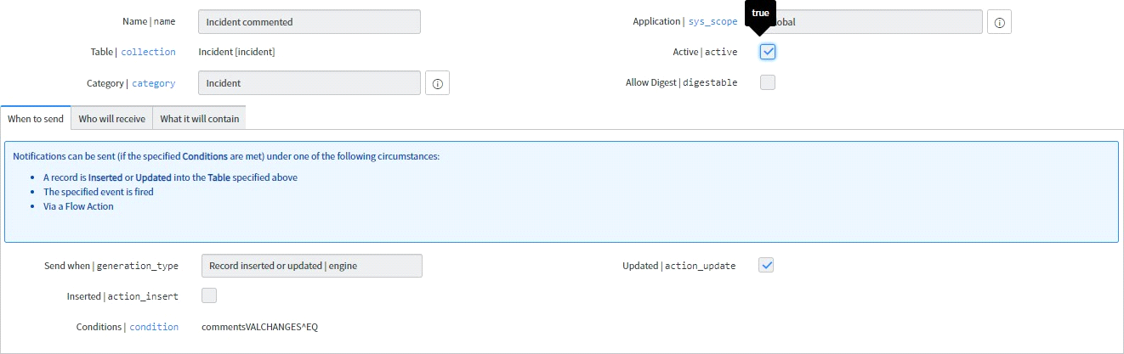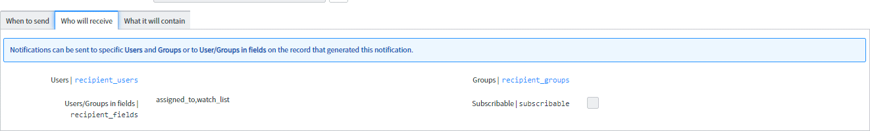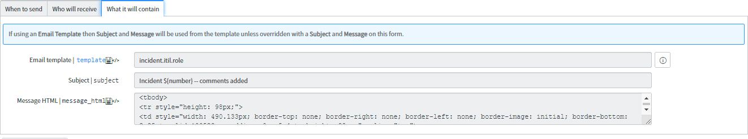10.8

**Reset Password:**

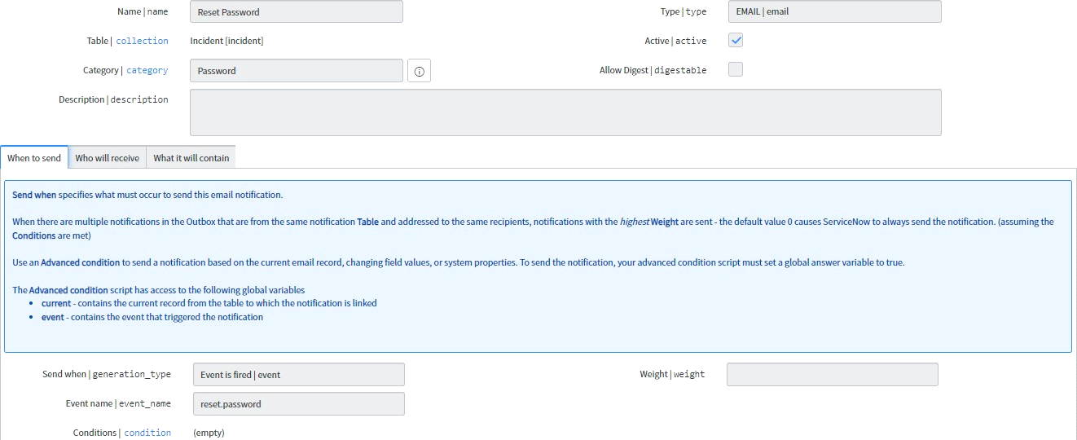1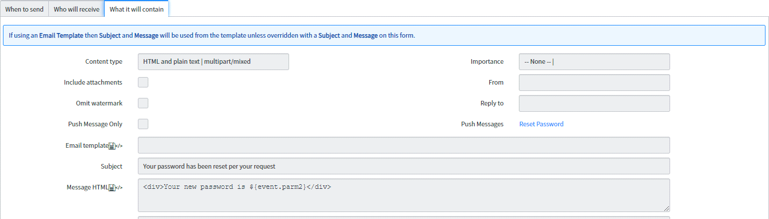

10.9

**Incident Closed:**

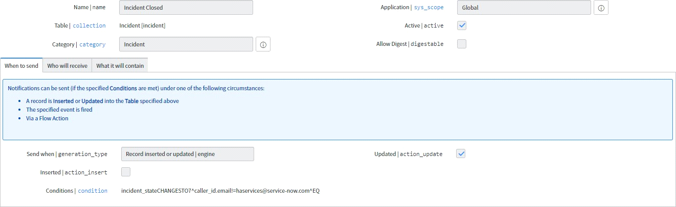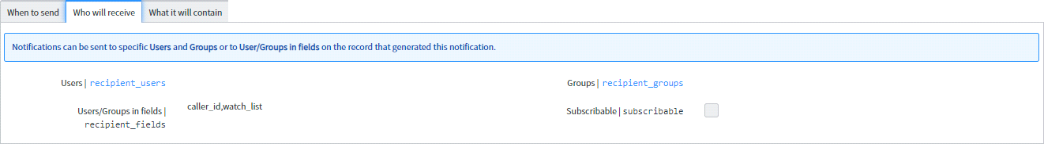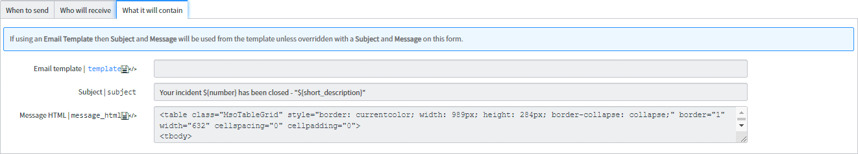

Img-10.10

**Incident Survey:**

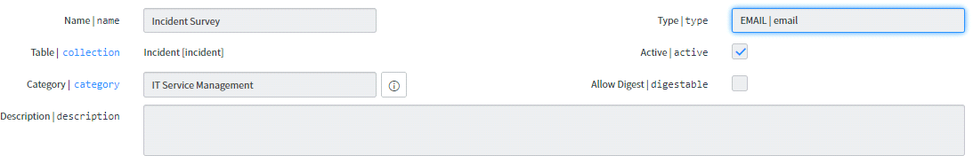

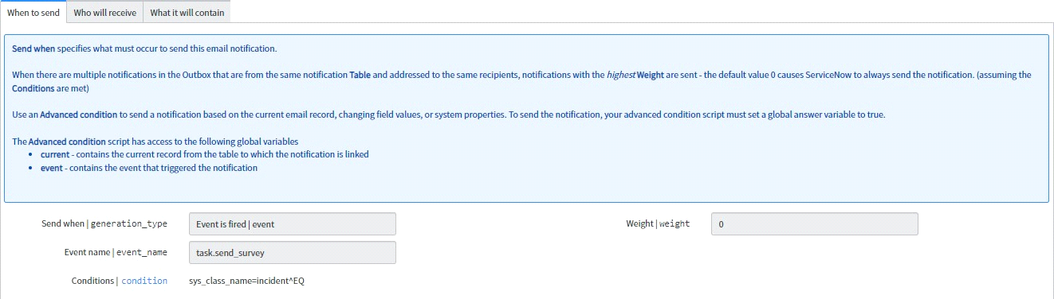

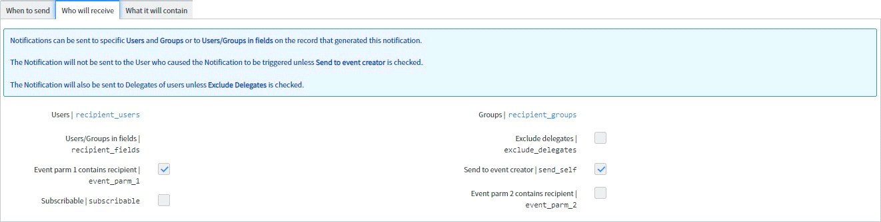

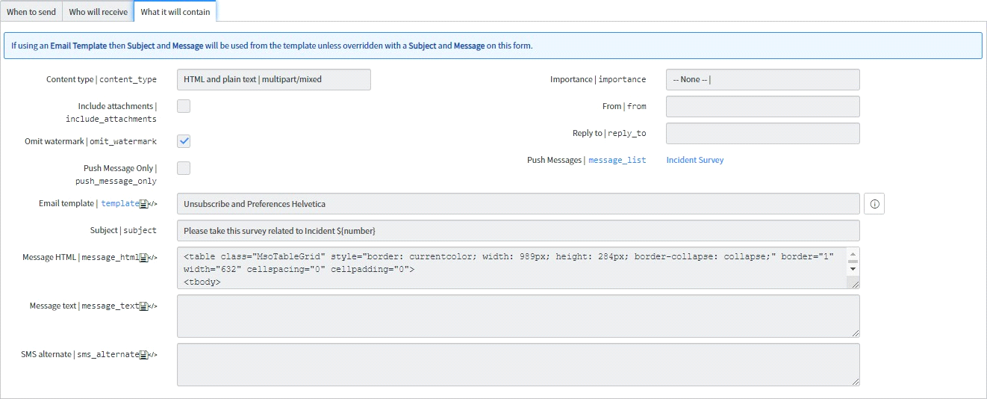 Img-10.11

**Service Level Agreement:(SLA)**

Configure a Service Level Agreement (SLA) to define a set amount of time for a task to reach a certain condition. This ensures that incidents are closed or resolved according to the expectations set for customers.

An SLA definition record defines the timings, conditions, workflows, and other information required to create task SLAs. This will enable you to use an SLA system for your group's tasks.

This feature is available to those with the dept_admin role only.

# CHAPTER 11

# ADVANTAGE

* **It saves more time:**

It saves time by ordering the bundle of items. It avoid for ordering the same bundle again and again and order the items in simple three click.

* **Increase Production**

The primary benefit of automated workflow is that it saves time. The term automation itself refers to mechanization and computerization, which in turn is the process related to saving time to complete a job with accuracy by improving the speed. Saving time for completing a job is directly related to saving the employee time so that she can get involved in other productive tasks rather than doing a job with mechanical repetition of steps.

* **Save costs**.

When an employee gets involved in more tasks that generate the most revenue for your business in the same working hours, it leads to more productivity. More productivity means saving more money for the organization as time and money are always interrelated.

* **User can trace their items:**

User can trace their items and it’s state. How many items has been ordered and how many time will take to reached item etc.

* **Process automate:**

All Process will be automated by work flow . Here after generating Request item task will be auto generate and notification will be auto fire.

# CONCLUSION

* Deliver a better experience with intuitive omni-channel self-service and two-way communication.
* Bring together the right agents to manage work and collaborate using one platform for IT processes.
* Reduce call volumes and deflect tickets using the self-service portal and ServiceNow® chatbots.
* Assign incidents to the right groups for faster resolution with the help of machine learning.

**REFERENCES**

**//use proper references**

1- https://link.springer.com/book/10.1007/978-1-4842-2571-4

2- https://link.springer.com/chapter/10.1007/978-1-4842-2571-4_12

3- http://wiki.servicenow.com/index.php?title=Differences_Among_Scripts

4-https://store.servicenow.com

5- https://link.springer.com/chapter/10.1007/978-1-4842-2571-4_2

6- https://link.springer.com/chapter/10.1007/978-1-4842-2571-4_10

7- https://link.springer.com/chapter/10.1007/978-1-4842-2571-4_4

8- https://link.springer.com/chapter/10.1007/978-1-4842-2571-4_8

9- https://link.springer.com/chapter/10.1007/978-1-4842-2571-4_1

10- https://link.springer.com/chapter/10.1007/978-1-4842-2571-4_9

11- https://link.springer.com/chapter/10.1007/978-1-4842-2571-4_11

12- https://link.springer.com/chapter/10.1007/978-1-4842-2571-4_7

13- https://link.springer.com/chapter/10.1007/978-1-4842-2571-4_6

14- https://link.springer.com/chapter/10.1007/978-1-4842-2571-4_14

15- https://link.springer.com/chapter/10.1007/978-1-4842-2571-4_13